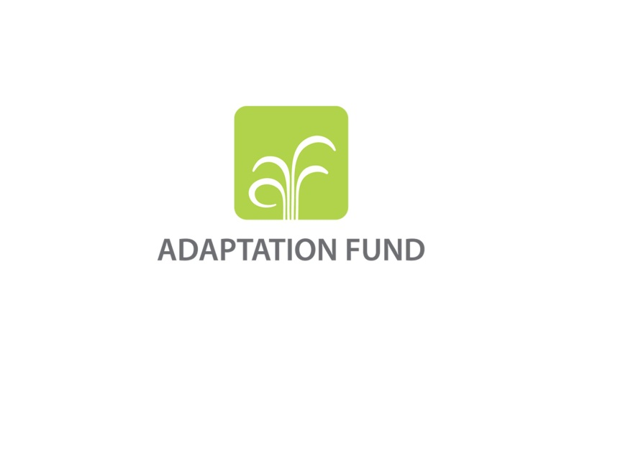

REQUEST FOR PROJECT/PROGRAMME
FUNDING FROM THE ADAPTATION FUND

The annexed form should be completed and transmitted to the Adaptation Fund Board Secretariat by email or fax.

Please type in the responses using the template provided. The instructions attached to the form provide guidance to filling out the template.

Please note that a project/programme must be fully prepared (i.e., fully appraised for feasibility) when the request is submitted. The final project/programme document resulting from the appraisal process should be attached to this request for funding.

Complete documentation should be sent to:

The Adaptation Fund Board Secretariat
1818 H Street NW
MSN P4-400
Washington, D.C., 20433
U.S.A
Fax: +1 (202) 522-3240/5
Email: afbsec@adaptation-fund.org
PROJECT/PROGRAMME PROPOSAL TO THE ADAPTATION FUND

PART I: PROJECT/PROGRAMME INFORMATION

Project/Programme Category REGULAR PROJECT (CONCEPT)
COUNTRY/IES: INDIA
TITLE OF PROJECT / PROGRAMME: Building Adaptive Capacities of Communities, Livelihoods and Ecological Security in the Kanha-Pench Corridor of Madhya Pradesh
TYPE OF REQUESTING ENTITY: NIE
NAME OF IMPLEMENTING ENTITY: National Bank for Agriculture and Rural Development
EXECUTING ENTITY (IES): 1) RBS Foundation India – promoted by The Royal Bank of Scotland
2) Madhya Pradesh Forest Department
AMOUNT OF FINANCING REQUESTED: US$ 2,514,561

Project / Programme Background and Context:

Provide brief information on the problem the proposed project/programme is aiming to solve. Outline the economic social, development and environmental context in which the project would operate.

Background
Climate change, its impact and attributes have become a matter of national and international importance. Impact of climate change on life and livelihoods is increasingly becoming visible as is evident by threats on food, water and energy security, health, migration and man – animal conflicts. If one were to assess from the other side of the spectrum, human activities are considered to be one of the key contributors to climate change. People are at the core; as those affecting and being affected by climate change. Though a global phenomenon, those who constitute the poor and marginalized and who are closely tied to a natural resource base for their livelihoods, food security and survival are most vulnerable to the impacts of climate change. India, a developing country with a massive population of 1.2 billion (Census, 2011) and very significant rural poverty, finds itself high on list of the most vulnerable nations to the impacts of climate change.
India, a mega diverse country with 2.4% of the world's land area, 7-8% of all recorded species, including over 45,000 species of plants and 91,000 species of animals (NBA, 2014) supports 16.7% of the global human population. In the country, the total forest cover is about 69.79 million hectares (ha) (ISFR, 2013) and with the country’s population of 1,2 billion, results in a 0.064 ha of forests per capita area availability against the world average of 0.64 ha (FAO, 2009). Thus, the pressure on the natural resources including forests is extremely acute.
Over time, in an effort to reduce the pressure on forests, India’s approach to forestry management has changed from production to conservation. This has stabilized its forest cover and has resulted from strong policies and legislation in place for the conservation of forests, wildlife and biodiversity. Enforcement of The Wildlife Protection Act (1972), The Forest Conservation Act (1980) combined with active judicial interventions has reduced diversion of forest land for non forestry purposes and has resulted in an increased share of protected areas in the country’s geographical area from 3.34% in 1988 to 5.07% in 2014 (NBA, 2014).
With increased population, the anthropogenic pressure on the natural resource base continues to remain a key concern of forest management in the country. The degradation of forests and its impact on biodiversity caused due to anthropogenic pressure coupled with climate change is evident from the decrease of 389.11 m³ in total growing stock, an indicator of the ability of the forest to sequester carbon, between two assessments of 2011 and 2013 (ISFR, 2013). The average growing stock of India’s forest is 58 m³/ha, and is far below the global average of 130.7 m3/ha and the south and Southeast Asian average of 98.6 m3/ha for the corresponding period (FAO, 2010).

Forests in India
A multilayered forest carries out a multitude of functions, ranging from enhanced carbon sequestration, supporting more biodiversity, to acting as a source for rivers and in providing better livelihoods, to name a few. High levels of biodiversity can provide ‘biological insurance’ against losses from disturbances, making the ecosystem more resilient and likely to recover, and allowing it to continue storing carbon in the long term (Bunker et.al 2005).
Degradation of these multilayered forests reduces their functionality and results in release of a large portion of carbon stored in above-ground vegetation to the atmosphere as carbon dioxide (and other greenhouse gases), or over time through the decomposition of debris. Carbon in soils following deforestation can also become a large source of emissions because of increased soil respiration with warmer ambient temperatures (Bormann and Likens, 1979). There is also loss of biodiversity.
According to the India State of Forest Report 2013 published by the Forest Survey of India (FSI, 2013), the total forest cover in India is 21.23% of its total geographical area. This cover includes all lands which have a tree canopy density of 10% and above with a minimum coverage of 1 ha. Furthermore, the carbon stock in Indian forest land was estimated to be 6,663 Mt. during 2004 and 6,941 Mt in 2011 resulting in a net increase in the carbon stock of 278 Mt, from forest land and land converted to forests. Thus, the forests of the country are playing an important role in removal of a significant amount of atmospheric CO2 which is a major cause of global warming.
Table 1.1: Change in Carbon Stock from Forest land, 2004 to 2013
Pools | Carbon Stock in forests (in million tons) |  | Net Change | % increase
Forest Cover | 2004 | 2013
Above ground | 2,101 | 2,192 | 91 | 4.3
Below ground | 663 | 694 | 31 | 4.6
Dead wood | 25 | 27 | 2 | 8.0
Litter | 121 | 130 | 9 | 7.4
Soil | 3,753 | 3,898 | 145 | 3.9
Total | 6,663 | 6,941 | 278 | 4.2
Source: Forest Survey of India - India State of Forest Report, 2013
However, the increase in carbon stocks does not reflect the ongoing degradation of the forests in India. This is made evident by Table 1.2 which shows that 1,991 sq. km of moderately dense forests have been converted to open forests which has resulted in forest areas that are severely depleted in terms of growing stock. The large expansion of forest cover under open forests (7,831 sq.km) does not offset the loss in growing stock due to reduction in moderately dense forests; thus, it is imperative to stabilize the dense forest cover as well while undertaking afforestation measures.
Table 1.2: Forest Cover of India
Class | Description | Area (sq. km) |  | Change  (sq. km)
Forest Cover | Tree Canopy density | 2011 | 2013
a) Very dense forest (VDF) | More than 70% | 83,471 | 83,502 | 31
b) Moderately Dense forest (MDF) | More than 40%; less then 70% | 320,736 | 318,745 | (1,991)
c) Open forests (OF) | More than 10%; less than 40% | 287,820 | 295,651 | 7,831
Total Forest Cover |  | 692,027 | 697,898
Source: Forest Survey of India - India State of Forest Report, 2013
Forest types: The Indian forest types include tropical evergreens, tropical deciduous, swamps, mangroves, sub-tropical, montane, scrub, sub-alpine and alpine forests. These are further classified into 16 vegetative types following Champion and Seth, 1968 classification. Among these 16 types, the most common are the Tropical dry deciduous (38.7%) Tropical moist deciduous (30.9%) and Tropical thorn (6.9 %) (WWF, 2011) These 3 types of tropical deciduous forests account for more than 76.5 % of forest area in India.
Forest ownership: 95% of the forests are owned by the state and the remaining 5% is divided into ownership by individuals, corporate and community groups. The administration control of the state owned forests are divided between the Forest department and the Revenue Department. Forests owned and managed by the Forest Department are legally protected as Reserve Forests, Sanctuaries and National Parks. These forests are considered as protected forests. Revenue forests present in the lands owned by the Revenue Department have multiple uses including developmental activities and thus have lesser protection and less strict rules and regulations.
  - Forest Communities
India has a significant human population living in and around its forests and while there is no official census figure on the forest dependent population of the country, estimates put it as approximately 200 million people (ICFRE, 2010), the majority of whom live below the poverty line. Livelihoods of this community are inextricably linked to forest ecosystems and they depend on the surrounding natural resources for a variety of goods and services. These include fruits, flowers, tubers, roots and leaves for food and medicines; firewood for cooking; materials for agricultural tools, housing purposes; fodder and grazing of livestock in forest; and many other non-timber forest products. Agriculture and livestock rearing are two major sources of livelihoods for these communities. Minority groups of tribal peoples comprise a high proportion of the population in typical forest communities -- these groups are particularly poor with lower than average literacy and inadequate access to information and resources for livelihood improvement or adaptation.
Forest resources form an integral part of agricultural systems, and farmers collect small timber, poles, litter and other materials for fencing and implements, manure and even pest management. However, agriculture inside forested landscapes is at subsistence levels and is constrained by low and unproductive land holdings, highly vulnerable weather conditions and is often prone to animal attacks. Crop damage/failure is common and augments the prevalent vulnerabilities and makes these communities fall back on the surrounding forest resources for survival, creating an ever increasing dependency pattern.
Forest communities’ rear livestock and it is a major source of livelihoods for the landless and an important support system for the farmers. As per the 19th Livestock census, the total livestock population of India is 512.05 million, out of which as much as 37% i.e. 190 million livestock depend on fodder derived from forests (ICFRE, 2010). Open grazing in the forest is the conventional rearing practice for forest dependent communities and has an adverse impact on the growing stock as well as the regeneration capacity of forests.
Apart from agriculture, livestock rearing and extracting forest resources for self-consumption, these communities sell forest products that account for as much as 40% of their cash incomes (Bharath Kumar et al, 2010). Thus, forests are also an important contributor to the rural economy around the forested landscapes. However, prevalent poverty caused by lack of cash earning alternatives often forces these communities to resort to over extraction of forest resources. It is thus evident that forests in India are under immense degradation pressure from sizable human and grazing animal populations that are highly dependent on forests for their survival.
To address the above situation, national policies and programmes have evolved to improve the resilience of the forest ecosystems through protection, conservation and afforestation, while still trying to enhance the livelihood security of forest dependent communities. Programmes like the Compensatory Afforestation Management and Planning fund (CAMPA), National Rural Employment Guarantee Act (NREGA), complimented by the establishment of Joint forest management committees in forest villages across India, have provided a support system to the forest dependant communities for employment while reducing degradation pressures. Support from international agencies like the Japan International Cooperation Agency (JICA) and the World Bank to these Government programmes for livelihood promotion, forest management, institutional strengthening, protection and conservation of forest biodiversity have fostered a conducive environment wherein these challenges can be addressed. However, while this transition has been successful in some ways, the lack of an integrated approach for landscape management has left most forest dependent communities with many vulnerabilities, thereby making them increasingly dependent on the continually degrading forests, and without other income earning alternatives.
  - Climate Change, Communities and Forests
Forests are highly sensitive to climate change. This has been shown by observations from the past, experimental studies, and simulation models based on current eco physiological and ecological understanding (IPCC, 2011). Prominent outcomes as a result of changes in climate in India include increases in temperature, precipitation and extreme weather events – including, floods and droughts – and seasonal shifts in rainfall patterns. With these changes, forests eco systems are experiencing increased incidence of, pests and pathogens, invasive species and landslides. Changes in climate are also expected to affect the tree physiology and phenology, and forest growth, and cause negative impacts to its biodiversity and the huge forest-dependent community residing in forest areas.
With reference to climate change, tropical forests are likely to be more affected by changes in soil quality and water availability (caused by the combined effects of changes in temperature and rainfall) than by changes in temperature per se. A decrease in soil moisture may accelerate forest loss in many areas where water availability is already marginal (IPCC, 2011). Further, in the Indian context, wherein a large population resides in its forests, and is hugely dependent on natural resources for their survival, the impacts of climate change are indirect and are induced by vulnerable communities that face failed agriculture and livestock caused by climate change and extreme weather events. These communities turn to forage/harvest in tropical forests as coping strategies for water, wood, fuel non wood forest products, food, fodder, medicines, etc., and even encroachment, that in turn causes deforestation and degradation. This causes large releases of carbon stocks into the atmosphere and also leads to erosion of functions and provision of goods and services making the entire ecosystem (including the biodiversity and communities) less stable and extremely vulnerable to climate change impacts and affecting their long term survival.
The objective of the proposed project is therefore to build the adaptive mechanisms towards climate change by building economic, social and ecological resilience of the target community and landscape through capacity building, governance, biodiversity management and developing climate resilient livelihoods.
  - Project Focus Area
As a mega diverse country, India has multiple landscapes which constitute several important floral and faunal assemblages, support diverse land use, forest protection regimes and traditional forest dwelling tribal communities. Of these, the Satpura – Maikal landscape (SML) is one of India’s largest strongholds of biodiversity, wildlife protection and natural resource - based livelihoods. Within this region, sits the Kanha-Pench corridor which connects Kanha and Pench Tiger Reserves and administratively spreads across Mandla, Balaghat and Seoni districts of the central Indian state of Madhya Pradesh.
The Kanha-Pench corridor provides important ecosystem services through its hydrology (e.g. part of the area is a watershed for the rivers Narmada and Mahanadi) and biodiversity (e.g. the parks support endangered and vulnerable species such as Tiger and Hard-ground barasingha). A diversity of human communities utilizes the forests in the area with varying intensity ranging from their livelihoods and survival. There is also an expanding network of road infrastructure that disects the landscape, agriculture, mining, hotels as well as other development related issues outside the protected areas.
In the last decade or so, the corridor has faced severe threats of degradation caused by an increase in anthropogenic pressure and climate change. Studies of the corridor area reveal that the state of the forest within the corridor varies from excellent patches with continuous regeneration to completely degraded patches that have been felled and over grazed. The villages located in and around the corridor exert biotic pressure on its natural resources as most of the local inhabitants depend on forests for their day to day sustenance. The prevailing situation in the landscape is further exacerbated by the impact of climate change. There is evidence to show that the rainfall pattern in the region has undergone a change in the past few decades impacting both forest resources as well as agriculture and hence the climate change is the overarching problem in the region.
Given the multipurpose scope and scale of the Kanha-Pench corridor area in providing services to people and wildlife alike, climate change stress has to be addressed from the onset. A mutually co-beneficial approach is required, wherein the community adopts practices that are resilient to climate change yet are supported by adapted livelihoods which reduce the strain on the flora and fauna of the corridor and thereby help to protect the landscape. The landscape’s sustainability through climate change adaptation measures will ensure livelihood, food, water, energy security and wildlife protection in the long run.
An introduction to the SML, the 3 administrative districts and the Tiger reserves it connects, the interdependencies between forests (natural resources) communities and climate change is provided below.
    - The Satpuda – Maikal Landscape (SML)
The SML is situated along the Satpuda and Maikal hill ranges of central India and spans over 15 administrative districts of three states, viz. Madhya Pradesh, Maharashtra and Chhattisgarh. It is a unique combination of various categories of protected areas and managed forests under various ecological regimes. The highlands comprising of the SML are primarily covered with tropical dry and moist deciduous forests and are a critical watershed and source of important rivers like the Narmada, Son and their tributaries. The SML is also categorized as global-priority Tiger conservation landscape due to its potential for providing connectivity to source populations thriving in its Tiger reserves through wildlife corridors. It is estimated that the SML supports 12% of India's Tiger population and contains 13% of India's Tiger habitat (Jhala et al. 2011).
However, like many other forested landscapes in India, the SML too is interspersed with human habitations. Several ethnic tribes inhabit the SML and reside in its many forest and revenue villages. The major ethnic tribes/groups in the landscape are the Baiga, Gond, Baharai, Korku, Ahir, Dhoba and Panka. Besides these scheduled tribes Yadav, Panwar, Banjara, Pardhi and Jharia communities also reside in the landscape. While farming is the major livelihood activity, most communities also depend on forest-based resources, small-scale mining and marginal labour for their livelihoods. Thus, the SML while supporting a wide variety of biodiversity also supports some of the most vulnerable communities of the country and thus has a very significant economic and biological value in terms of the broad range of services it provides.
Recognizing the importance of forests in the landscape, protected areas including 5 wildlife sanctuaries and 6 Tiger Reserves have been established in the SML to protect its biodiversity and regulate dependency of communities’ on its forest resources. The Tiger reserves established are Achanakmar, Kanha, Pench (Madhya Pradesh), Pench (Maharashtra), Satpuda and Melghat and enjoy some degree of connectivity in the form of 4 natural forested wildlife corridors viz. Achanakmar - Kanha; Kanha - Pench, Pench-Satpuda, and Satpuda-Melghat. The importance of these corridors can be understood by the below points as given by McEuen, 1993:
- Enhanced immigration, which will support genetic flow, increased genetic diversity and enhance overall metapopulation survival in connected patches.
- Provide opportunity to avoid predation.
- Provision of fire escape function.
- Accommodation of range shifts due to climate change.
- Maintenance of ecological process connectivity.
These corridors are functional structures in the SML and perform a multitude of functions – thus their connectivity is critical to ensure the long term functionality of the landscape and the survival of the flagship specie viz. Tiger, and the other important species that exist in it. However, over time the increase in population, changes in protection regimes and land use for developmental and tourism activities, urbanization, dependencies of vulnerable communities and impacts of climate change in the SML have resulted in degradation and fragmentation of the forest areas and posed challenges for maintaining contiguity across the landscape. These challenges call for a holistic landscape approach which is required across both public and private lands to protect and manage natural ecosystems and ensure forest connectivity in the SML.
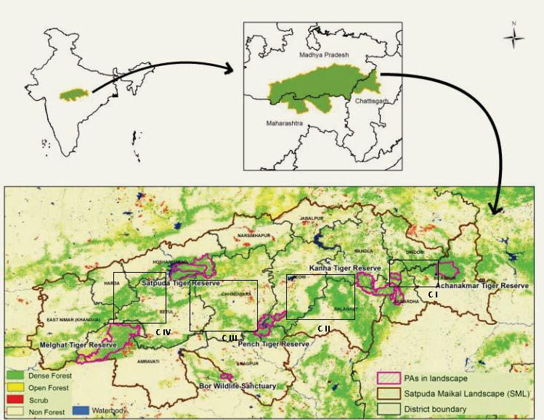
Map 1.1: The SML and the four corridors connecting Tiger reserves in the SML shown as - CI, CII, CIII and C IV. (Source: WWF, 2012)

    - The Project Districts
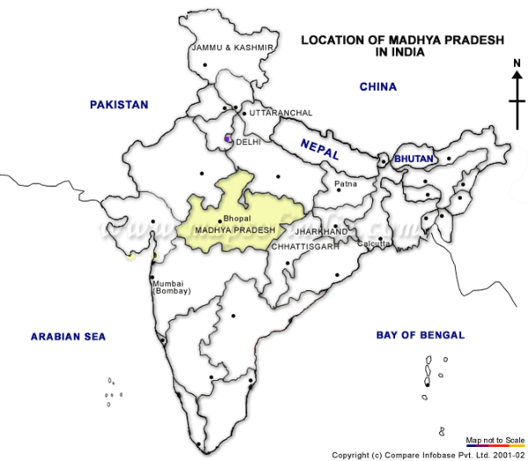
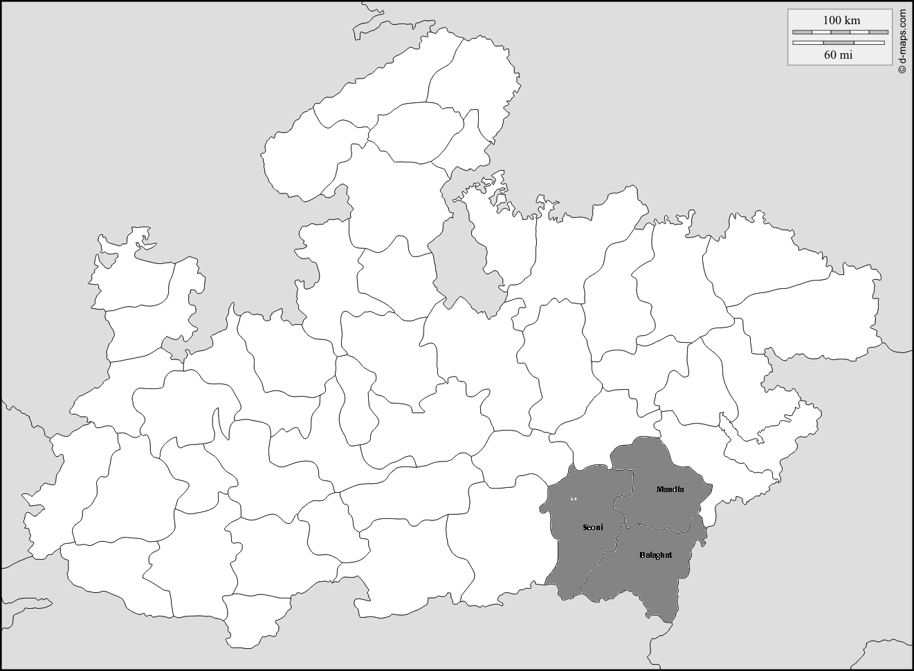
The KPC spreads across 3 administrative districts of the Central Indian state of Madhya Pradesh viz. Balaghat, Mandla and Seoni. These districts lie in the south eastern part of the state as shown in the Map 2.

Map 1.2: Location of the three project districts (Source: Compare Infobase, 2002)

Topography: The altitude in these districts varies from 400 m to 700 m from the mean sea level and gentle slopes can be observed all along the districts. The tracts in the district of Mandla are relatively plain and areas near Balaghat and Seoni have mild undulating terrain.

Climate: These districts have a sub-tropical climate; summers are dry and extend from April to June with maximum temperatures ranging between 43’C - 45’ C. These are followed by the monsoon from July to September with an average annual rainfall of 1350 mm and winters are pleasant with average temperatures ranging between 10’C – 15’C during November – February but can drop to a minimum of 0’C in some parts.

Forests: The forest area in these districts is characterized by a homogenous mix of various forest types. Overall, forests ranges in Mandla and Balaghat are mixed deciduous and dominated by Sal (Shorea Robusa); while teak (Tectona Grandis) and bamboo (Dendrocalamus strictus) are the dominant species in the Seoni forest ranges. Table 1.3 shows the district wise forest cover with respect to its total geographical area and changes in it as per the latest assessment done by the Forest Survey of India

Table 1.3: District Forest Cover
District | Geographical Area (GA) | 2013 Assessment of FSI
 | (Sq. km) | VDF | MDF | OF | Total | % of GA | Change in sq. km since 2011
Balaghat | 9,229 | 1,328 | 2,690 | 960 | 4,978 | 54 | (19)
Mandla | 5,800 | 751 | 1,204 | 880 | 2,835 | 49 | 5
Seoni | 8,758 | 240 | 1,803 | 1,039 | 3,082 | 47 | (1)
Total | 23,787 | 2,319 | 5,697 | 2,879 | 10,895 | 50 | (15)
Source: Forest Survey of India - India State of Forest Report, 2013 VDF=very dense forest; MDF=medium density forest; OF=open forest.

As shown in the above table 50% of the district geographical area is under forest cover. Also, there has been a decrease in forest cover in Balaghat and Seoni, the main reasons for the decrease is the encroachment on forest land, mining activities and submergence. While the increase in forest cover in Mandla is due to afforestation measures taken in the district.

Demographics: Highlights
- Total population in the 3 districts is 4.13 million. The decadal population growth rate (2001 – 2011) is 17% with an incremental population increase of 0.58 million people. The growth rates are similar to the national decadal growth rate of 17.64%
- The population is these districts is 87% rural with a decadal growth rate of 14% and incremental population of 0.44 million. Urban population is 13% with a decadal growth rate of 33% and increment of 0.13 million (2001 – 2011)
- Overall density is 175 people per sq. km with a decadal growth in density per sq. km of 16.6%. (2001 – 2011)
- Sex ratio is 1003, which is high compared to the state’s average of 931 and national average of 943. Literacy rate is 73.20% which is slightly lower than the national rate of 74.04%.
- Scheduled tribes (indigenous people) in these districts comprise 37% of the total population which is extremely high as compared to the national average of 8.6%.
- 52% of the population in these districts is working and the composition of shown in the chart below. 80% depend on agriculture (cultivators and agriculture labourers) for their livelihoods. Furthermore, more than 80% of farmers are marginal (less than 2 ha of cultivated area).
- The total livestock population is 2.77 million (Livestock Census, 2012); thus, the livestock to people ratio is as much as 0.67:1 (for every 1 person there is 0.67 cattle)
- Population living below the poverty line is 51%

Chart 1.1: Working Population in Balaghat, Mandla and Seoni Districts
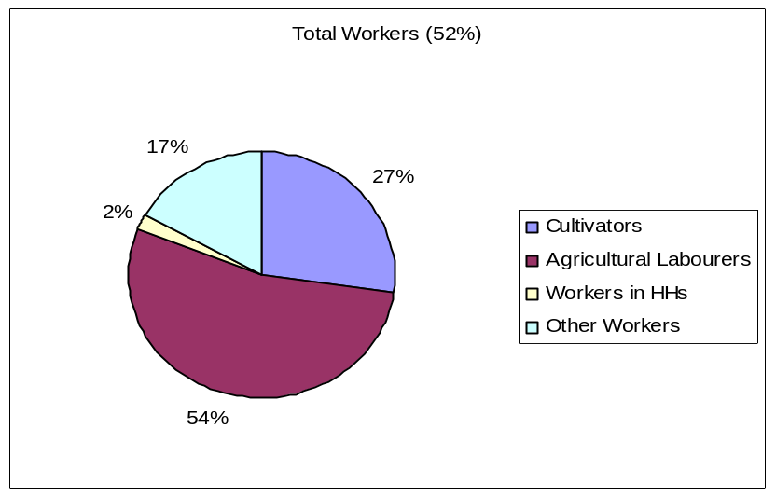
Source: National Census 2011
Climate Change and Vulnerability: The State Action Plan for Climate Change has derived climate projections for the state of Madhya Pradesh for 2030s (2021-2050) and 2080s (2071-2098) using PRECIS (Providing Regional Climate for Impact Studies). According to the projections on temperature variations it is expected that the average surface daily maximum temperatures, in the period of 2030s will rise by 1.8-2.0°C throughout Madhya Pradesh and the daily minimum temperatures are projected to rise between 2.0°C to 2.4°C during the same period; the eastern half of the state (where the Balaghat, Mandla and Seoni districts are located) will experience more warming than the western half.
Projections of rainfall in Madhya Pradesh for the period 2021 to 2050 indicate that there is likely to be decrease in winter rainfall moving from eastern part to western part of the state. Pre – monsoon rain is expected to the rise in the southern part of the state and thus will have an effect on the Balaghat, Mandla and Seoni districts. Monsoon precipitation for the period of 2071 – 2100 is expected to be 1.45 times the current observed precipitation in Mandla and Northern Balaghat (SAPCC, 2012)
Also, to assess the vulnerability of the districts in Madhya Pradesh a composite index was developed by multivariate analysis of individual indicators (social, economic, agriculture, water resource, forest and climate) which are vulnerable to climate change. A Vulnerability ranking (from 1 to 50, 50 being the most vulnerable) was then assigned to all the 50 districts of Madhya Pradesh based on the corresponding Vulnerability Index. In this exercise, the districts ranked as:
Table 1.4: Vulnerability Assessment of the KPC Districts
KPC Districts | Baseline | Mid Century | End Century
Balaghat | 42 | 41 | 41
Mandla | 48 | 46 | 40
Seoni | 38 | 45 | 43
Source: State Action Plan for Climate Change, Madhya Pradesh 2012
    - The Tiger Reserves
Tiger Reserves are areas notified under the section 38V of the Wildlife Protection Act, 1972 to provide inviolate habitats to the Tiger and stabilize their dwindling population and conserve the eco system in the country. The KPC connects two such Tiger reserves viz. Kanha and Pench.
Kanha Tiger Reserve: Kanha Tiger Reserve is one of the first designated Tiger reserves under the Project Tiger, Wildlife Protection Act 1972 and is managed by the Field Director’s office, Mandla. It comprises three areas, an inviolate core zone (940 sq km), a multiple use buffer zone (1,009 sq km) and a satellite micro core (110 sq km). It is internationally renowned for its typical Central Indian floral and faunal attributes and conservational measures and is a huge wildlife tourist destination.
Besides a viable population of the Tiger, and an endemic population of hard ground barasingha (Cervus duvauceli branderi), the reserve harbours 43 species of mammals including leopard (Panthera pardus fusca), wild dogs (Cuon alpinus), sloth bear (Melursus ursinus), gaur (Bos gaurus), chital (Axis axis), sambhar (Rusa unicolor), striped hyena (Hyaena hyaena) and jackal (Canis aureus indicus).
Under the tourism policy of Kanha TR, its management has created a small tourism zone in the reserve’s core area. It consists mainly of the lower slopes and valleys of the reserve and has excellent Sal & Bamboo forests, extensive grasslands and perennial water bodies. The zone coincides with excellent wildlife habitat and is home to many ungulate species, which in turn provide substantial prey base making this zone a haven for the Tiger.
On an average 143,000 tourists visit Kanha every year (16th October – 30th June). About 14% of these tourists are foreigners. To accommodate these tourists, the tourism industry has developed significantly over the past decade in and around the TR which has had both positive and negative impacts on the landscape and communities.
Chart 1.2: Tourists in Kanha Tiger Reserve, 2006 to 2014
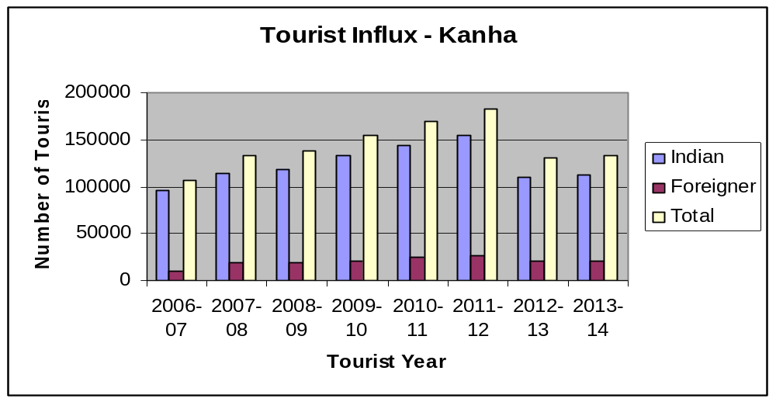
Source: Field Director’s Office, Kanha Tiger Reserve
Pench Tiger Reserve: Pench was declared a Tiger reserve in 1992, with an inviolate core zone of 411 sq. km and a buffer area of 768 sq km. The landscape is famous for being the inspiration behind Rudyard Kipling's 'Jungle Book' and like Kanha, is a major wildlife tourist destination. Pench Tiger reserve spreads across two states viz. Madhya Pradesh and Maharashtra, and the Pench Tiger reserve (Madhya Pradesh) is managed by the Field Director’s office, Seoni.
The Pench Landscape is equally rich in biodiversity like Kanha. The undulating topography supports a mosaic of vegetation ranging from moist, sheltered valleys to open, dry deciduous forest. The high habitat heterogeneity favours high population of Chital and Sambar which provide an ideal prey base for the thriving predator population of Tigers, Leopards and Wild Dogs.
On an average 57,000 tourists visit Pench (MP) every year (16th October – 30th June), 8% of these tourists are foreigners. The tourism industry, although not as developed as it is in Kanha, is gradually expanding in Pench as well and bringing with it both positive and negative impacts as it is in Kanha.
Chart 1.3: Tourists in Pench Tiger Reserve (Madhya Pradesh), 2006 to 2014
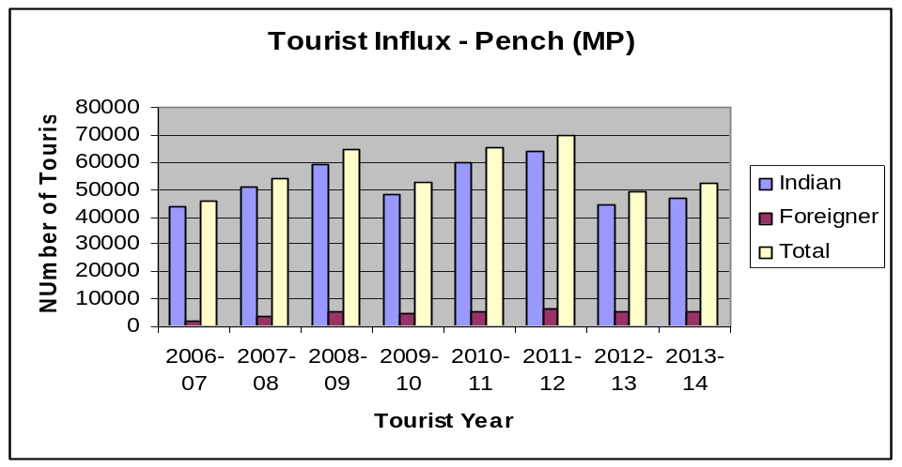
Source: Field Director’s Office, Pench Tiger Reserve
The Interlink
In the 3 districts of Balaghat, Mandla and Seoni, the forests are spread over more than 50% of the geographical area (Table 1.3), furthermore, these districts have a population of 4.5 million people, 87% of whom are rural, and 37% of are indigenous and share an age old relationship with forests. Also, more than 80% of the working population in these districts depends on agriculture, 80% of them are marginal farmers. Livestock is the other major livelihood in the districts with 0.67 cattle for every person.
As the information suggests, people in these districts are highly dependent on natural resources and in turn on the climatic conditions. Moreover, prevalent poverty combined with the existing livelihood patterns suggests that the population is highly vulnerable economically and during economic troughs retreat to the forest resources as a coping mechanism. Thus, one can say with high confidence that these forests and people living in these areas share an inextricable link and the forests play an important role in the day to day life of these people and the economy as a whole. This is further indicated by the overall decrease in forest area in these districts (15 sq. km) in recent years through increasing developmental and livelihood related pressures.

Continuing increase in population and density reflected in figures of decadal growth rate of population (17%) and density per sq. km (16.6%) combined with the dependency on forests for cash incomes which is further augmented by their vulnerabilities against the impacts of climate change, suggests that the forest areas in these districts face grave threats of becoming irreversibly degraded and fragmented.

Also, apart from increasing vulnerabilities in these communities which indirectly leads to forest degradation, climate variations are also predicted to have direct implications on forest degradation. As temperature increases and rainfall pattern changes, forest growth, and regeneration of forests in all parts of Madhya Pradesh, including these 3 districts, is likely to be affected. It is likely that higher rates of degradation of forests and soils would occur covering large areas there by affecting biodiversity and hence resulting in widespread degradation.

  - The Kanha-Pench Corridor (KPC)
The project will be implemented in the KPC which is one of the 4 forested wildlife movement corridors in the SML. As mentioned already, KPC is located in south eastern part of the Indian State, Madhya Pradesh and spreads across three districts viz. Balaghat, Mandla and Seoni.

The KPC connects two protected areas viz. the Kanha Tiger reserve and the Pench Tiger Reserve and is seen as a critical link to the long term survival of the flagship specie – the Tiger. The Kanha and Pench Tiger landscapes with a population of 67 Tigers (range 60 – 74) and 54 Tigers (range 44 – 65) respectively support meta population of Tigers and the connectivity between these two Tiger reserves is of critical importance for the long term survival of the Tiger.
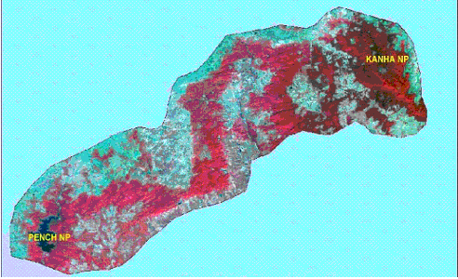
Figure 1.1: Satellite imagery of the Kanha and Pench Tiger Reserves and the KPC (Source: KPC project report)

Ensuring the continuity of the KPC is also important for maintaining the ecological balance of the larger landscape of the SML, as the KPC is an important functional unit within the landscape. However, conservation of the KPC is a challenge as it falls under various protection regimes; supports a substantial human and livestock population; and faces fragmentation pressures from developmental projects and climate change. It is thus felt that conservation of this corridor is a multi-dimensional challenge and needs to be addressed in a holistic manner.

    - The Kanha-Pench Landscape Symposium
A step towards adopting a multidimensional approach has been initiated with the organization of the Kanha-Pench Landscape Symposium (KPLS), a bi-annual, 3-day symposium that brings together researchers, conservationists and managers working in the Kanha-Pench Landscape to share their perspectives and findings, and develop networks for collaborative future work in the region.

The first symposium was held at the Kanha Tiger reserve in 2014 and included participants with research and management expertise in varied environment-related disciplines, including conservation, ecology, wildlife science, climate and social science. The participants continue to work on issues directly related to the sustainable management of the Kanha-Pench landscape and its biodiversity, and have a continued interest in actively contributing to science-informed management and conservation. The Royal Bank of Scotland Foundation, India was one of the participating institutions at the symposium.

The participants discussed with concern the with the many competing objectives of conservation, livelihoods of local people, and infrastructure to meet development goals and balancing these objectives was presenting managers of the landscape with difficult tradeoffs. Discussions concluded with the reaffirmation that a participatory and holistic approach and facilitating mutual understanding and dialogue between researchers and managers could help deliver science based conservation and better outcomes for both wildlife and people in the landscape.

    - The KPC management plan
Progressing from harvest to sustainable usage and from conservation of Protected Areas to management of landscapes, the Madhya Pradesh Forest Department has prepared India’s first ‘corridor’ restoration plan between the Kanha and Pench Tiger reserves. The objective of the plan is to facilitate the genetic mixing and smooth movement of Tiger and other wildlife species between Kanha and Pench Tiger reserves.

The KPC management while focusing on the Silivicultural and Wildlife management aspects of the corridor also proposes the measures to be adopted for addressing the threats to the corridor. The plan aims to utilize a set of on-going state and central programmes such as the NAPCC, SAPCC, ‘Green India Mission’, MNREGA, National Water Mission amongst others. It also serves as an important document for outlining its area, biodiversity, biogeography, jurisdiction regime and weak links.

As per the KPC management plan the total area of the corridor is 3,162.23 sq. km. including 2,552.12 sq. km. of forest land and 610.11 sq. km. of revenue land. Of the 2,552.12 sq km under Forest Department, 2,352.25 sq. km is reserve forests and 199.87 sq. km is protected forests. Furthermore, the total length of the outer periphery of this corridor is 806.73 km and 248 forest villages lie within this periphery while 194 revenue villages lie outside the corridor and boundaries of these villages touch the outer periphery of the corridor. The total number of households in these 442 villages is about 80,000 with a population of over 420,000. The management plan further goes on to identify 6 weak links areas in the corridor which contains 43 villages in total and proposes interventions specific to each weak link that are needed to improve forest cover and animal movement.

Table 1.5: Villages in the KPC, Administration Categories and Districts
District | Forest Villages inside KPC | Revenue Villages outside but on the periphery of KPC | Total no. of Villages
Balaghat | 158 | 90 | 248
Mandla | 10 | 31 | 41
Seoni | 80 | 73 | 153
Total | 248 | 194 | 442
Source: KPC Management Plan

Though the management plan is a step towards adopting a landscape approach of conservation by the Forest Department and has elements of a multidimensional and holistic approach, certain dimensions such as livelihood generation cannot be fully realized because the work required is outside the 'business as usual' scenario and the MP Forest Department does not have the required resources. For this, it has combined its efforts with civil society organisations and corporations that focus on livelihood generation through natural resource management.

    - RBS Foundation India
The Royal Bank of Scotland (RBS) is a large international banking and financial services company. Headquartered in Edinburgh, RBS serves over 24 million customers worldwide. As part of its sustainability agenda, RBS believes in inclusive growth and demonstrates it by supporting local communities in the countries in which it operates. In India, since 2007 through RBS Foundation India it has implemented a program of “Supporting Enterprise“. The objective of the Supporting Enterprise program is to foster economic integration and financial inclusion by developing innovative models that generate sustainable livelihoods for those communities that live in remote geographical areas and don’t have access to mainstream markets. These are forest dwelling communities that are dependent on natural resources such as forests for their livelihoods. RBS Foundation India has supported 91,000 households in 11 states across India.

The RBS Foundation India supports creation of sustainable livelihoods for the vulnerable communities through grant funding and strengthens the governance of the ecosystem resource extraction by these communities through Eco Development committees/Forest protection committees/Biodiversity Management Committees or 'Paryavaran Samitis' so as to reduce anthropogenic pressures in the forested landscapes across India. Considering the vulnerability of the community and forests in the central Indian landscape, RBS FI implements/has implemented 7 projects with a total commitment of $2.55 million (1 USD = INR 63).

As an active management entity in the Kanha Pench Landscape and other SML units, RBS FI has been working closely with the Madhya Pradesh Forest Department (co – applicants to the proposal) and were also participants at the KPLS held at Kanha. From the discussions held over time with the Forest Department and during the symposium which dealt with the conservational and community needs of the KPC, RBSFI with its experience of implementing projects listed in Table 1.6, has taken a lead to adopt a holistic approach of implementation which addresses the threats to the KPC landscape and contributes towards ensuring the long term functionality of the KPC.

Table 1.6: Seven Projects supported by RBS Foundation India in the SML
Project Details | Issues | Outcomes Achieved/Expected | Impacts Achieved/ Expected
1 : Livelihoods in Mandla  - Status : Completed  - Villages: 3, Household: 300  - NGO Partner: Watershed Organization Trust  - Duration: 3 years (2009 -11)  - Funding (million INR) 16.2 | - Depleted ground water resources  - Degraded soils  - Low agriculture productivity  - Deforestation  - Migration | - Increase in water levels  - Improved soil water conservation  - Improved agriculture practices adoption  - Alternate livelihood – Petty trades, nursery, goatery, NTFP aggregation  - Community Governance | - Improved food security  - Options of alternate livelihoods locally  - Drinking water security  - Improved biodiversity  - Improved ability to take cohesively take decisions
2: Livelihoods in Bandhavgarh  - Status : Ongoing  - Villages: 8, Household: 417  - NGO Partner: Indian Grameen Services  - Duration: 7 years (2010 – 17)  - Funding (million INR): 19.7 | - Crops loss due to raiding by wild herbivores  - Low agricultural productivity  - Lack of irrigation  - Lack of alternate livelihood opportunities | - Bio fencing  - Adoption of cash crops and non farm livelihoods  - Micro irrigation facilities  - Women led collectives | - Increase in cropping intensity and food security  - Crop loss due to farm raids reduced  - Reduced dependency on forest  - Women empowerment
3: Livelihoods in Kanha  - Status: Completed  - Villages: 15, Household: 1800  - NGO Partner: Foundation for Ecological Security  - Duration: 3 years (2010 – 13)  - Funding (million INR): 13.6 | - Degraded & Depleted forest resources  - Lack of community cohesiveness  - Stress on livelihoods | - Improvement in governance. Self regulations for extractions  - Regeneration of commons for fuel and fodder needs  - Improvement in income | - Improved understanding and ownership towards natural resources and forest produce.  - Increase in house hold incomes  - Improved participation of women in village level institutions.
4: Livelihoods in fringe of Kanha National park  - Status: Ongoing  - Village: 40, Household: 2500  - NGO Partner: Foundation for Ecological Security  - Duration: 3 years (2013-16)  - Funding (million INR): 19.6 | - Villages with high dependency on protected forest  - Over harvesting of Forest resources leading to degradation  - Lack of alternate opportunities  - Lack of community participation in conservation | - Community Governance for resource management  - Development of Village forest and management of usufructs rights  - Alternate livelihoods to enhance and secure income  - Improvement in agriculture productivity | - Improvement in income  - Controlled and managed forest harvest  - Improved HOUSEHOLD and landscape resilience  - Pilots for use of alternate to fuel wood and efficient cooking stoves
5: Livelihoods in Balaghat  - Status: Ongoing  - Village: 135, Household: 10000  - NGO Partner: PRADAN  - Duration: 5years (2013- 16)  - Funding (million INR): 54.9 | - Extremely high dependency on forest resource  - Small land holding and low cropping intensity  - Lack of market knowledge  - No Collective action in village development activities. | - Community level governance through collectives  - Capacity building on Natural resource management , improved agriculture practices and availability of alternate livelihood  - Drudgery reductions for women. | - Successful demonstration for improved agricultural productivity and alternate livelihoods  - Pilots for use of alternate to fuel wood and efficient cooking stoves  - Community involved in local level decisions.
6: Livelihoods in Mandla  - Status: Ongoing  - Village: 6, Household: 624  - NGO Partner: Watershed Organization Trust  - Duration: 3 years (2014- 17)  - Funding (million INR): 21.3 | - Water level depletion  - Soil degradation  - Low agriculture productivity  - Deforestation  - Migration | - Alternate livelihood – Petty trades, nursery, goat rearing, NTFP aggregation  - Community Governance with focus on women empowerment  - Soil and water conservation | - Improved food security  - Options of alternate livelihoods locally  - Enhanced natural resource generation  - Reduction in women drudgery
7: Livelihoods in Hoshangabad  - Status: Ongoing  - Village: 13, Household: 600  - NGO partner: India Grameen Services  - Duration: 3 years(2014- 17  - Funding (INR million): 15.3 | - Loss of livelihood due to resettlement from Critical Tiger Habitat  - Availability of cash, but limited income generating assets  - Limited skills to initiate agriculture in a different agro climatic zone  - Lack of market knowledge | - Capacity building and awareness on suitable agricultural practices  - Provision of irrigation facilities  - Create market linkages  - Skill trainings to enhance employability.  - Women centric livelihood activities. | - Stabilized income sources  - Optimum utilizations of assets and cash ( received from relocations)  - Women and Youth contribute to the Household income
Source: RBS Foundation India data
The proposed project apart from utilizing the experience gained by implementation of projects given in table 1.6 also aims to incorporate the learning from 2 other projects that have been implemented in the state of Madhya Pradesh by the forest department and were funded by the World Bank and GEF - UNDP, details of the projects and learning of the same are given below.

    - World Bank and GEF Projects in the SML

Table 1.7: Two Projects supported by World Bank and Global Environment Facility in the SML

Project Name, Duration, Funding and Scope | Key Components | Expected Outcomes | Lessons learned
- World Bank. 1995. India - Madhya Pradesh Forestry Project..  - 5 years (1995 to 1999)  - US $ 58 million equivalent  - The main beneficiaries of the project were tribal people and forest fringe villages belonging to the poorest sections of the society. The project incorporated specific measures to safeguard the interest of the landless and the women, through participation in village communities, employment preference and gender sensitive monitoring | Assist the Government of Madhya Pradesh in forestry sector development through:  - Management development to improve forestry management by changing the approach of MPFD.  - Forest development involving (a) Promotion of natural forest regeneration by enrichment planting and improved silvicultural practices (b) Village resource development programmes based on participatory training  - Extension technology and research programmes with specific provisions for infrastructure and facilities  - Biodiversity conservation through improved management of 12 high priority protected areas | The project was expected to:  - Increase the production of NTFP and animal products directly or indirectly and supply of wood to forest based industries.  - Natural regeneration on 1, 60,000 hectares of forest land, ensuring participation of 1140 village communities in forest management.  - Establish village resource development programmes and Eco development programmes.  - The economic rate of return for the project as a whole, in terms of direct forestry outputs and research component was estimated at 11.5% | The important lessons learned were  - A long-term commitment is needed by the Government and the donor agency, to mobilise villagers support to resource conservation.  - Flaws in the legal and incentive framework need to be addressed.  - The banks involvement in the forest sector needs to be seen in the larger and longer term in context of poverty reduction and its monitoring.
- GEF- India Eco development Project.  - 5 years (1997 to 2002)  - US $ 28 million equivalent  - The main beneficiaries were globally important protected area ecosystem and people in and around in these areas. Majority of the beneficiaries were tribal and the vulnerable forest depended communities. The project specifically addressed interest of the landless and the women). One of the project sites were 99 villages situated within a 3 km radius of the Pench Tiger Reserve. | The project objectives were:  - To improve capacity of PA management to conserve biodiversity and increase opportunities for local participation.  - To reduce the negative impacts of the local people on Biodiversity and thereby increase supportive collaboration.  - To develop more effective and extensive support for eco development.  - To ensure effective management of the project  - To prepare future biodiversity projects. | The output consisted of:  - Broadening the focus of PA planning and management  - Restore ecosystems, improve fire and poaching control and improve staff efficiency  - Enabling communities to meet their requirements of PA resources sustainably,  - To gain wider public support, to maintain the quality control, accountability and adaptive management mechanism. | The lessons learned from the project were  - Baselines and benchmarks well established which helped identification of area adjacent to PA boundary for Eco development coverage.  - Development of robust micro planning process and appropriate capacity building of PA staff, NGOs, and members of Eco Development Committee (EDCs)  - Support of Credible NGO is required for effective implementation.  - Establishment of revolving fund for EDCs through micro credits  - Enhanced status and empowerment of ‘special need groups’ due to representation of poor tribes and women in EDC

The knowledge based developed by the above projects in terms of baselines (both socio economic and ecological), forest management practices, dependency pattern of the vulnerable communities, and institutional arrangements will serve as a basis to understand the adaptive needs of the KPC and its community which will help in further streamlining the proposed adaptive strategies and ensure optimum utilization of resources available for the project.
Thus, the proposed project aims to build on the experience of RBS Foundation India, MP Forest Department, World Bank and GEF – UNDP, GIZ projects, and the knowledge gained through the developed network of collaborators by the Kanha-Pench Landscape Symposium. This will be used to factor in the interlink as highlighted in Section 1.2.4 and ensure enhanced resilience of the KPC and communities to climate change and thereby improve the functionality of the entire landscape.

  - Livelihoods of KPC communities
Integral to the holistic approach is the need to understand the community practices towards their livelihoods. As per the KPC Management plan 442 villages are settled in and around the KPC. These villages support about 80,000 households having a population of more than 420,000 people, 32% of whom are indigenous and share an inextricable relationship with the forests of KPC. As much as 36% households fall under the poverty line, 79.6% practice agriculture, 17.8% are labour/landless, and 2.6% practice professions such as black smith, carpentry, masonry, etc. Communities collect forest produce for meeting their cash income needs and as a coping mechanism for failed agriculture and other livelihoods.

Table 1.8: Livelihoods and Landless in percentage by District
District | Agriculture | Labour/landless | Other
Balaghat | 78.8 | 15.6 | 5.6
Mandla | 69.8 | 28.7 | 1.5
Seoni | 90.3 | 9.1 | 0.6
Average | 79.6 | 17.8 | 2.6
Source: KPC Management Plan
Livelihoods of most of the inhabitants of the KPC follow a seasonal occupation cycle as below:
Table 1.9: Seasonal Occupational Calendar
Month | Activity
March – April | Collection of non timber forest produce like Tendu leaves, Mahua, Aonla, etc.
May – June | Migration to nearby towns as agricultural and construction labour
July – October | Agriculture activity
Nov – Feb | Migration to nearby towns as agricultural and construction labour
Source: RBSFI data

The livelihood options for forest villages are constrained by regulations on land use. There is also a lack of cottage industries and non land based activities such as handicrafts, vocational skills, poultry, and value addition to NTFPs, etc. While livelihood options for revenue villages are less constrained, they still face economic stresses due to limited land availability and lack of other livelihood opportunities. Furthermore, due to low literacy levels in the region technology uptake is poor. The main livelihood practices of the community are discussed below.

Agriculture: Agriculture is the main occupation of the communities living in the KPC, and as seen in the tables 1.10 and 1.11, 84% farmers have land holdings of less than 2 ha and 74% net sown area is unirrigated, implying that most of the farmers can practice only one rainfed crop during the year. The single crop produced is mainly paddy and the few who have irrigation availability grow wheat combined with pulses and minor millets in small areas during the Rabi season. Independent studies conducted to assess crop productivity suggest that the productivity of major crops viz. paddy and wheat, is below the state average and overall agriculture is devoid of improved agricultural practices, irrigation facilities and access to good quality inputs.

Table 1.10: District Composition of Big and Marginal farmers in the KPC
District | Big farmers (land more than 2 ha, percent) | Marginal farmers (land less than 2 ha, percent)
Balaghat | 22.5 | 77.5
Mandla | 33.5 | 66.5
Seoni | 11.7 | 88.3
Average | 16.4 | 84.6
Source: KPC Management Plan

Table 1.11: District Land Classification: Dry land and Irrigation
District | Irrigated | Un-irrigated
District | (percent of total agricultural land)
Balaghat | 40.1 | 59.9
Mandla | 7.4 | 92.6
Seoni | 24.4 | 75.6
Average | 26.2 | 73.8
Source: KPC Management Plan

Also, loss of produce to raiding by wild herbivores is another challenge faced by the communities and as much as 90% of the households report 15 – 25% crop damage due to raiding (Aggarwal, 2011). The compensation scheme put into place is defunct and the basic reason for this is the involvement of the Revenue Department in the process. Other compensation schemes related to human injury/death or cattle kill are under the control of the Forest Department and are functioning satisfactorily. While in the case of crop damage compensation, the claimant is required to apply to the Patwari (Land clerk of the Revenue Department), who assesses the amount of damage done in monetary terms. Most of the villagers complained about the patwari rarely visiting the field to assess the damage caused leading to no compensation to the farmer.

Considering the above challenges it is evident that agriculture, despite being the major livelihood of KPC communities is highly vulnerable and can barely meet the subsistence needs of the communities and forms only a meagre part of household cash incomes.

Climate variability with respect to temperature and precipitation which has a direct impact on agriculture has been identified in the M.P. State Action Plan for Climate Change (SAPCC). The plan indicates rise in temperature, increase in intensity and delay in the onset of monsoons in the KPC districts.

Climate projections in the MP SAPCC indicate a further increase in temperatures by 2050s and an uneven distribution of rainfall across the state, with perceptible decrease in rainfall during winter period and almost no change in rainfall during monsoon with respect to current climate. However, the frequency and intensity of droughts and heavy rainfall events with respect to the current situation is likely to increase further (MoEF, 2010). These predicted changes are expected to lead to spatial and temporal shift of cropping centres and decline of productivity of crops. Also as the evapo-transpiration rate increases with increase in temperature, it will lead to depletion in moisture retention capacity of the different soil types and can pose a threat to agriculture in the region.

On the other hand, increase in intensity of rainfall is likely to lead to faster run off causing higher soil erosion in the ravine areas with little or no scope of ground water recharge in the alluvial plains causing further depletion in the ground water tables in MP, including the 3 project districts. The status of soil health and its fertility is likely to deteriorate further with increase in soil erosion and higher temperatures, causing stored carbon to be released from the soil. Also it is likely that the onset of monsoon may shift from June to first fortnight of July in the state which would likely affect the cropping sequence and sowing time. Therefore, even if farm inputs are adequately provided through development of effective delivery mechanism, changes in climate in the future may lead to conditions which may not support sustainable crop production as productivity of crops is an integrated process of favorable climatic conditions as well as farm inputs.

Furthermore, between 1998 and 2004, there has been 15.3% rise of water draft from ground water sources in Madhya Pradesh (MP SAPCC). Analysis of observed rainfall data for the period 1961-2003 indicates an already decreasing annual trend. Also, as per the report the trends of heavy precipitation (>100mm) events in the last 50 years is increasing as compared to precipitation events less than 100mm. Which means that not only the lower rain fall receipt is decreasing the ground water recharge over the years, but the increase in heavy precipitation events leading to higher run off are also not facilitating adequate ground water recharge. Water use efficiency in irrigation is generally very low and this is an area of major concern in view of resource depletion. The challenge is to increase efficiency in irrigation and enhancing agricultural productivity through other improved technologies.

Livestock: Livestock in the region are mostly of the indigenous breed, and although most of them are unproductive they are an important part of subsistence of the KPC community and are used to meet the household milk requirements, provide agricultural manure and till agricultural fields.
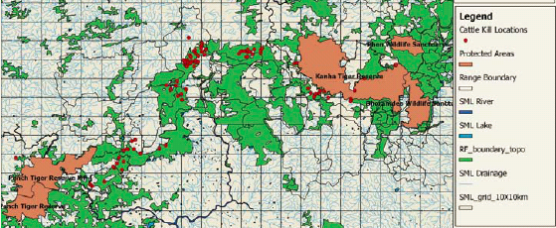
Map 1.3: Cattle kill locations in the KPC (Source: WWF, 2012)

As per the KPC management plan the ratio of human population to that of cattle population in the corridor area is 1.28:1, that is, for every 100 people, there are 78 cattle. The estimated population of the corridor area is about 0.42 million, making the cattle population in the 442 villages an estimated 0.32 million. Furthermore, on the basis of the number of different types of cattle, the average cattle unit per person comes to be 0.71. Accordingly, the total number of cattle units in the corridor works out to 0.23 million cattle units which need 2.5 tonnes fodder annually for one cattle unit. Thus, a total of 0.57 million tonnes of fodder is required for all the cattle in the villages falling in the corridor. (KPC Management Plan)

Fodder availability from agriculture is very limited as most of it is rain fed, hence the fodder requirements are mostly met through open grazing in the surrounding forests. It is estimated as much as 95% of these cattle are left to graze openly in the forests and they exert tremendous pressure on the KPC and results in low fodder availability for the wild ungulates and the degradation of the forests.

Also, with the predicted climate variability, frequency of crop failures is expected to rise which in turn will result in even lesser fodder availability for the livestock. Expected increase in local temperatures will result in grasses drying faster and reducing palatability and making livestock move deeper into the forest for grazing. This may further augment the cattle killing in the region by predators like Tiger and leopard and result in retaliatory killing of these predators by the community as cattle are an important part of their livelihood. Furthermore, stamping on the forest ground by cattle can also result in compaction of soil which can further reduce the forests regeneration ability.

Non Timber Forest Products (NTFPs): NTFPs form a significant part of the annual income of a typical household in the KPC and on average contributes about 30% of the total cash income per year (Sushant, 2013). Communities practice collection of Tendu (Diospyros melonoxylon) leaves and Mahua (Maduca indica). Tendu plants are pruned in the months of February and March and the mature leaves are collected after about 45 days. The leaves are collected in bundles of 50 leaves and are sold to the Madhya Pradesh Minor Forestry Produce Cooperative Society at the rate of Rs.75 per 100 bundles. Mahua is collected from April end throughout May. The income from sale of Mahua flowers varies from Rs.1,000-1,200 per household per season, with 15-20 days of hard work. (Thakur & Srinu). Mahua flowers are collected, distilled and consumed as liquor, or dried and eaten, sometimes with corn-flour, in periods of extreme drought.

Like in other forested landscapes, a complex combination of economic and other factors affect the rate of NTFP extraction in KPC. Studies elsewhere in India suggest that the rate of extraction of NTFPs is linked to the degree of agricultural stress. For example, when low agricultural productivity occurs in a drought year, tribals in KPC tend to extract and sell more NTFPs to meet the food security needs of their households. Since NTFPs like Mahua (Maduca indica), Harra (Terminalia chebula), Behera (Terminalia bellirica), Chironji (Buchanania lanzan) have a ready and accessible local market, income from NTFPs helps compensate for lean harvests. Moreover, the typical flowering season of many of the major NTFPs coincides with the agricultural post-harvest period in March. Consequently, not only do tribals have sufficient time to go to forest areas to extract NTFPs, but they can also determine the level of extraction based on the results of the agricultural harvest.

However, communities have observed a significant change in the phenology of local mahua, and suggest a gradual shift in fruiting and flowering period from mid-March to mid-February. The shift in the flowering season of mahua reflects a discernible change in the local forest ecology and can be perceived as a climate change outcome. Early onset of flowering in NTFP’s like Mahua during the harvest period leaves less time for the community to collect this NTFP. Such situations have a direct implication for the food security of the region. As the availability of major NTFPs diminishes, the number of livelihood alternatives for meeting subsistence needs decreases.

Table 1.12: Decline in Harvest of NTFPs per Household
NTFP Species | Local  Name | Uses | Years
NTFP Species | Local  Name | Uses | 1995 | 2005 | 2010
Anogeissuslatifoloa | Dhaora | Construction, gum used as medicine | 100 | 50 | 10
Buchnanialanzan | Chironji | Food | 100 | 80 | 50
Chlorophytumtuberosum | Safed Musli | Medicine | 100 | 50 | 10
Cassia tora | Charonta | Medicine (snake bite, food | 100 | 70 | 40
Celastruspaniculatus | Malkangni | Medicine (head ache) | 100 | 50 | 10
Curculigoorchioloides | Kali musli | Medicine (jaundice, asthma) | 100 | 80 | 75
Diospyrosmelanoxylon | Tendu | Bidi, Medicine (snake bite), Edible fruit | 100 | 80 | 70
Emblicaofficinalis | Aonla | Medicine, Edible fruit | 100 | 40 | 10
Madhucaindica | Mahua | Liquor, Oil, Food | 100 | 90 | 75
Schleicheraoleosa | Kusum | Medicine (arthritis), edible fruit, oil | 100 | 75 | 50
Terminalia belerica | Bahera | Medicine (bronchitis, asthma), Food | 100 | 50 | 25
Terminalia chebula | Harra | Medicine (cough) | 100 | 50 | 25
Source: Sushant, 2013

Fuel Wood: As per a study conducted by the World Wildlife Fund (WWF, 2012) it was found that average household consumption of fuel wood in the KPC is 4,760 kg per annum. Considering the fact that about 80,000 households live in and around the KPC, the total fuel wood extracted annually comes to about 38,000 tons. The fuel wood extracted is mainly used for cooking, heating and selling purpose. While extraction of only dead wood is allowed legally from the forests, communities often resort to cutting trees to meet their fuel wood requirements when dead wood in not available easily.

The main tree species extracted are Saaja (Terminalia tomentosa), Dhawa (Anogeigus latifolia), Ledia (Eucalptus globules), Harra (Terminalia bellarica), Palash (Butia monosperima), Sal (Shorea robusta) and Girchi (Alnus nitida). Some of these are also important NTFP species and thus form an important source of cash income for the communities; thus cutting of these NTFP bearing species can also adversely affected the availability of NTFPs to the community and impact their livelihoods. Extraction of fuel wood in such an unsustainable manner will result in serious degradation and fragmentation to the KPC and threaten its vital role as a wildlfe corridor.

Migration: As per the KPC management plan, on average about 9.25% of the total population migrates to find manual labour work in the nearby cities of Jabalpur and Nagpur from the KPC villages to earn cash income for the family. Migration mainly happens during the non-agricultural season (February – May) due to lack of wage-labour opportunities in the region. Males migrate to find work opportunities and women stay back in the villages to care for children and family elders, and work under government and non-government sponsored labour schemes to earn cash income. Males prefer not to work under these schemes primarily because these opportunities are not available throughout the year, the supply of labour exceeds demand, and the remuneration offered is less than one-third of the wages paid in industrial hubs. (Sushant, 2013)

  - Threats to the KPC
KPC is a critical functional unit in the larger landscape of the SML with vital ecological and carbon sequestering value. It also supports a substantial human population that suffers from chronic poverty and is extremely vulnerable socio- economically and in terms of climate variations. KPC faces threats that can cause irreversible degradation and dilute its functionality and pose challenge to the survival of the rich biodiversity and large community it supports. These threats to the KPC can be categorized into i) Threats from Communities; ii) Threats from Climate Change and iii) Threats from Development are discussed below.

Threats from Communities: Forests are an integral part of the life of the communities living in and around the KPC and their well-being is directly linked to the well-being of the forest. But over the years, the increase in population of people and livestock in the region combined with the prevalent vulnerabilities in these communities have created acute pressure on the forest resources and has led to over extraction causing widespread degradation. The degradation if not controlled poses huge fragmentation threats to the KPC. The level of degradation upon KPC forests can be demonstrated by the existing extraction by forest communities discussed below:

- Dependency of 420,000 inhabitants on the KPC in terms of fuel wood, fruits, tubers, timber for house construction and agricultural implements.
- 230,000 cattle units in the KPC, with a fodder dependency of about 500,000 tons annually.
- Fuel wood (for household usage and sale) dependency of 38,000 tons per annum.
- Extraction of NTFPs for household and selling purposes comprising 30% of the total cash income.

Table 1.13: Key Vulnerabilities in the KPC Communities
Vulnerability | Cause | Impact | Coping mechanism at present without any intervention
High frequency of Crop failure on account of climate change | Lack of irrigation facilities, technical know-how and poor quality of inputs.  Erratic monsoons, droughts, hail storms and variation in climatic conditions other impacts attributed to climate change. | Food security not met and inadequate cash income for meeting household, medical and educational expenses. | Higher extraction of forest produces (NTFPs, fuel wood) for sale.  Distress migration to the nearby towns for employment. Sale of livestock.
Unsustainable extraction of forest resources | Lack of knowledge, Coping mechanism against above vulnerabilities including impacts due to changing weather patterns. | Over extraction and climate change causing degradation of forests resulting in habitat destruction, reduction in forest produce availability, high man animal conflicts. | Collectors move further inside the forests for extraction of forest resources.
Crop raiding by wild herbivores | Proximity of agricultural land to the forests, cultivation of palatable crops, lack of farm protection | Food security not met and no cash income with the household for meeting household, medical and educational expenses. Retaliatory killing of herbivores. | Crop damage compensation by revenue department (defunct in most cases).  Higher extraction of forest produce (NTFPs, fuel wood) for sale.  Distress migration to the nearby towns for employment. Sale of livestock.
Depredation of livestock by Tiger, Leopard and other predators. | Unproductive cattle, lack of farm fodder leading to open grazing of cattle inside the forest area. | Adverse impact on agricultural inputs and nutritional value of the Households. Retaliatory killing of the predators. | Compensation from forest department. (Functional, but valuation of the cattle is extremely low).
No alternative livelihoods available during lean agricultural periods | Lack of skills, lack of cottage industries, non availability of local labour from government schemes | No cash income, adverse impact on the social fabric; increase in women drudgery due to male migration. Health, accommodation issues for the migrants | Distress migration to the nearby towns for employment. Sale of livestock.
Source: RBSFI data

To alleviate poverty and reduce pressure on natural resources it is important to remove the vulnerabilities prevalent in the communities. Furthermore, with the gradual climatic variations leading to frequent livelihood failures each successive year, these vulnerabilities and dependencies will only increase. Thus, it is imperative to make these communities more climate change resilient in terms of livelihoods if the continuity of the KPC is to be maintained and improved.
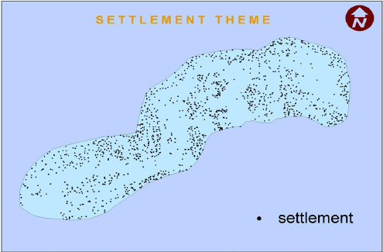
Figure 1.2: Settlement theme in the KPC indicating the proximity of human settlements to its forests Source: KPC project report

Threats from Climate Change: Predicted climate changes are expected to have impacts on the livelihoods of the KPC community, increase vulnerabilities and deplete economic, social and physical resources. It is thus expected to have indirect climate induced fragmentation pressures on the KPC. Climatic variations are also expected to have direct impacts on the KPC landscape. Some of these changes are already being noticed through changes in floral and faunal phenology e.g. there are noticeable changes in the movement of the Indian Bison which have started descending the hilly areas earlier year after year. Communities have also noticed changes in the flowering patterns of many trees including Mahua which has started flowering earlier in the year during Feb – March compared to late March - April. It is felt that if such trends continue they can augment the vulnerabilities and along with it the degradation of the KPC and result in faster fragmentation.

The Madhya Pradesh State Action Plan for Climate Change suggests that predicted changes in temperature and rainfall will result in higher rates of degradation of forests and soils covering large areas in South Eastern Madhya Pradesh. This is evident from the predicted vegetation change shown in the map which clearly indicates the widespread change in vegetation in the KPC by the year 2020.
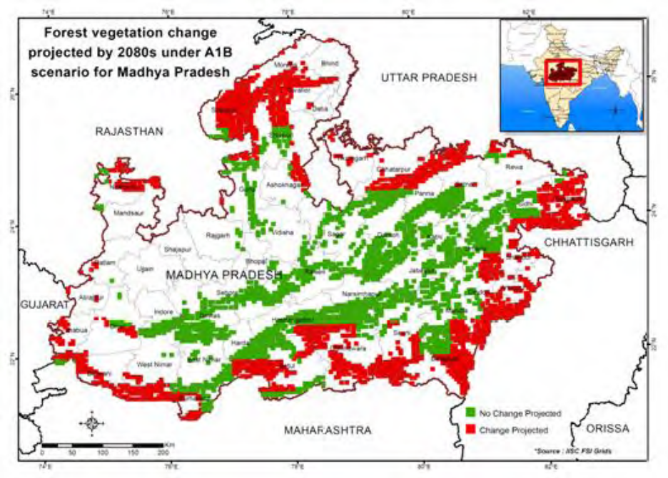
Map 1.5: Forest Vegetation Change Projected towards 2080s with respect to 1970s (Source: SAPCC, 2012)

The expected impacts of Climate change on the KPC landscape are as below:
- According to studies, around 20% of the plants experienced early flowering in the 1990s with the decadal increase of 15 days while some of the species experienced late flowering. (Fitter et al 2002). Change in flowering time will lead to irregular fruiting of NTFP and other ecologically important trees of the KPC. For short-lived seeds, the condition of the ground is of utmost importance and it becomes receptive just before the seed fall in a normal ecological cycle. For e.g. the seeds of Shorea robusta have a viability of just one week. If the seeds fail to find the receptive substratum, they will die which is expected to adversely impact its regeneration. The same holds true for other tree species as well. Thus changes in climatic conditions can alter flowering cycles and receptivity of forest grounds and impact the regenerative ability of the KPC forests.
- Expected increase in temperature in the KPC districts can lead to faster drying of grasses and other vegetation. This both reduces palatability and acts as a secondary source material for fire. The early drying of grasses can affect the movement and population of the prey-base populations who mainly feed on grasslands and meadows that exist in Kanha and Pench Tiger reserves which in turn can have impact on the Tiger and other predator population. Furthermore, high fire material availability on the forest floor can enhance the risk of causing higher damage in case of forest fires and lead to widespread forest degradation.
- With the change in moisture and temperature regime in the region, there is a high probability that there will be a shift in the ranges of the pollinators leading to absence of required pollinators in the corridor area which in turn will affect natural regeneration. Furthermore, changes in climate can also result in increased outbreak of epidemic in the forest areas of KPC, and while there are no specific studies showing correlation on the same in KPC, several studies across the globe have proved that insects are prone to adapting to climate change. Warmer temperatures work to their favour. Generally rising temperatures around the world as a consequence of climatic change are increasing the frequency and intensity of pest outbreaks accompanied by range shifts of pests (Bale et al. 2002; Gitai et al. 2002; Jepsen et al., 2008). If this is the case, insects like Sal Borer which have previously destroyed Sal (Shorea Robusta) forests in the region previously can prove to be devastating for the forests of KPC and cause irreversible damage to the forests.

The climate threats the project is seeking to address are threefold: (1) the vulnerabilities of the local community arising from changing weather patterns (2) the local community’s unsustainable dependency on the natural resources arising from their vulnerabilities caused due to changing weather patterns (3) the shifting of vegetation boundaries, change in species composition and shift in ecosystem boundaries affecting hydrology.
Given the importance and interdependency of the project area as a habitat for the local community and flaura and fauna alike, the project will address the above mentioned threats to ensure strong functionality of the ecosystem of the Kanha- Pench corridor while the local community’s needs are still fulfilled through climate change adaptation.

Threats from Development: With increased population there are increased developmental demands in the KPC, and these developmental activities also pose a fragmentation challenges. The major developmental activities in KPC are:

Road construction and widening: A number of new roads have been constructed in the KPC over the past few years to connect its many villages and nearby towns. At the same time the earlier single-lane roads are being converted into two-lane roads. Development in the road network has led to increased numbers of vehicles and speed. This in turn has impacted animal movement and has increased the road kills of wild animals. While there are many roads inside and passing through the corridor (Map 1.6) the major fragmentation threat is being posed by the recent developments on the widening of the National Highway 7 which will result in clearance of forests, cause fragmentation and hinder animal movement, the widening of this road is on hold as per stay given by National Green tribunal during May, 2015. Besides this there are two other roads viz. Keolari – Balaghat and Nainpur – Balaghat that are major threats to the animal movement.
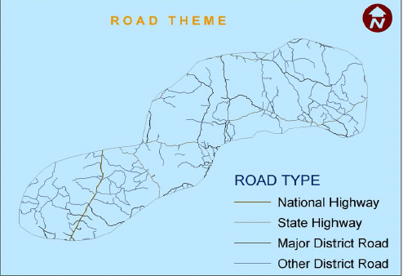
Figure 1.3: Expanding Road Network inside the KPC (Source: KPC project report)

Railway gauge widening: A narrow gauge railway line from Jabalpur to Gondia via Nainpur and Balaghat exists from pre independence times. It passes through Mandla and Seoni districts and then enters the Balaghat district. The length of the railway line passing through the KPC is 49.70 km. Of this distance, 17.98 km of the line lies in the forest areas of the corridor while 31.72 km in the revenue areas. The line crosses forest land on 10 patches, 9 of which lie in the Balaghat district. Presently, trains on this narrow gauge run at 40 km/hr, and are low in frequency, thus cause minimal or no impact to animal movement. However, if the gauge conversion of this railway line changes from narrow to broad gauge the speed of trains is expected to rise from 40 km/h to 100 km/h. The frequency of trains is also expected to rise substantially as it will cut the distance between two major cities viz. Jabalpur and Nagpur by 150 km’s.
Thus, the conversion is expected to have major implications on the animal movement as development of the railway track will fragment the corridor as it will involve clearing of forests, noise from the high speed trains, elevated construction of railway tracks and high speed of the trains will restrict animal movement and may lead to an increase in accidents causing deaths to the wildlife.
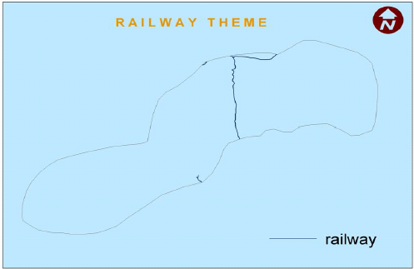
Figure 1.4: Railway line - Narrow gauge passing through KPC (Source: KPC project report)

Tourist Facilities: Kanha & Pench Tiger Reserves are famous wildlife destinations and attract tourists from all over India and the world. The tourists’ influx to these Tiger reserves showed increasing trends in the past decade and have stabilised in the recent years due to carrying capacity revisions/ entry fee hikes by their respective management. However, tourism has brought along development of tourist facilities that have might have long term implications of animal movement.

The mushrooming of resorts especially around the Kanha TR has led to fragmentation of the corridor and is become a major bottleneck in animal movement from Kanha TR to the corridor landscape. These resorts have boundary walls and barbed wire fencing around them which act as hurdles for animal movement.

The resorts also contribute to environmental impacts on the surrounding ecosystem. Solid waste generated by these resorts (including plastic, tin and even glass) is burned in piles on the ground which burns at low temperatures and produces air pollution and particles. It tends to smoulder and release toxic smoke over long periods, especially when wet. Also, the burning of these wastes produces bottom and fly ash. Bottom ash is relatively coarse, non-combustible, generally toxic residue of burning waste that accumulates in the open pit. This is a major source of Leachate formed by accumulation of bacteria and other possibly harmful dissolved or suspended materials. If uncontrolled, leachate can contaminate both groundwater and surface water sources.
Fly ash is made of light particles which is carried out by combustion gas and is laden with toxic metals, dioxin/furan and other products of incomplete combustion. This can easily enter the water cycle and contaminate the streams and rivers.

Table 1.14: Pollutants released by Burning of Waste
Pollutants | Environmental Impacts
Aldehydes; Dioxins and Furans;Heavy metals such as mercury;Hydrochloric acid;Particulate matter (PM);Polynuclear Aromatic Hydrocarbon (PAH’s) | Increases toxic loading on the environment;  leads to contaminated water/soil, affects  animals’ health. Some of these pollutants can  enter the food chain of livestock and wild animals.
Volatile Organic Compounds (VOC’s) & Sulphur Oxides | Causes vegetative damage, can contaminate  soil/water; contributes Sulphur Oxides to acid rains.
Source: Sen, 2011

Liquid waste generated by the resorts is primarily domestic sewage which is released directly into the forest area without treatment. Domestic sewage contains concentrations of suspended and dissolved organic and inorganic substances. Among the organic substance present are carbohydrates, lignin, fats, soaps, synthetic detergents, proteins and their decomposition products. The inorganic substances include a variety of toxic elements such as arsenic, cadmium, chromium, copper, lead, mercury and zinc. The toxic material present in domestic sewage is not only harmful at phytotoxic levels; they can also harm the faunal life by contaminating the aquifers and other water bodies. (FAO)

The resorts also have unsustainable practices of sourcing fuel wood. They are allowed to buy fuel wood to meet their requirements only from a forest department managed wood depot. However, the resorts often resort to sourcing wood from locals as it is cheaper which further adds to the pressure on the surrounding forests.

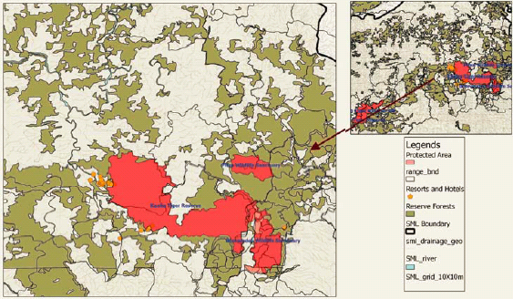

Map 1.4: Bottleneck Created by Resorts at the start of the KPC near Kanha Tiger Reserve (Source: WWF, 2012)

Project / Programme Objectives:

List the main objectives of the project/programme.

The objectives of the project are to build the adaptive capacity of the community in the backdrop of declining productivity of the land and ecosystem and contributed to by climate change. It proposes to build resilient livelihoods by addressing the key threats to the region viz. unsustainable extraction of resources, degrading soil and water regimes, changing weather patterns and lack of coping mechanisms.

Therefore, the project aims to adopt a community centric approach and achieve a significant reduction in the prevalent vulnerabilities and increase their adaptive capacity through:
- Enhancing community ownership towards the forests resources through awareness programs, robust community based institutions, and by promoting conservation by sustainable harvesting.
- Building sustainable and climate resilient livelihoods to enhance incomes of the community and promote vocational skills and alternative fuel sources to reduce community dependence on the natural resources.

Threats of climate change to the KPC will be addressed primarily by addressing the prevalent vulnerabilities of the communities to climate change and managing their dependency pattern on the KPC forests. Furthermore, it will be addressed by facilitating improved decision making of the Forest department through identifying the specific climate change threats and measures to be adopted to negate the same. Thus the specific objectives of the project could be summarized as below:
Specific Objectives:
- To understand the Kanha-Pench landscape dynamics through socio-economic and ecological assessment and planning and prepare baseline report
- To build robust community institutions and prepare micro plans at village/cluster level for responding to climate change and
- To enhance adaptive capacity of the community and landscape through climate resilient agricultural practices, diversified livelihoods, vocational skills, improved livestock rearing practices and energy efficient mechanisms

Threats posed by development activities will be addressed by raising the awareness levels of the relevant line departments responsible for management of forests and natural resources and private parties that base their businesses on access to the forests. Overall the developmental threats to KPC are proposed to be addressed through:
- Raising awareness levels and sensitivity towards the importance of the KPC.
- Facilitating efficient decision making through improved information about the impacts of specific developmental activities in the KPC.
- Undertaking applied research on the major threats and providing guidance on best practices from India and other countries on climate change adaptation and sustainable natural resource management in forest environments.

Project Coverage
The project proposes to work towards enhancing resilience of 7,500 households which represent the most vulnerable communities in the KPC landscape.

A household vulnerability assessment will be conducted using tools like participatory rural appraisals and with consultations with the Forest Departments and partners of RBS FI, and these households will be identified based on the following criteria:
- Extent of dependency on the forests and natural resources for subsistence and livelihoods i.e. households with high dependence and sensitivity to climate variations will be given priority.
- Current status of agriculture – households having small and marginal land holdings, limited water availability, practicing traditional practices and prone to crop raiding will be identified.
- Lack of alternates – households that have limited opportunities to access alternative livelihoods on account of limited infrastructure, lack of educational qualification and immobility due to socio – culture aspects of rural living.

The details about the identified 7,500 households and the villages that represent the most vulnerable communities in the landscape will be included in the Detailed Project Report.

Project / Programme Components and Financing:

S No | Project Components | Expected Outcomes | Expected Outputs | Budget (in USD)
1 | Integrated socio - economic and ecological assessment and planning | Improved understanding of prevalent landscape dynamics in reference to climate change | 1.1 Baseline report covering the threats, climate change trends and its impacts on livelihoods, biodiversity and ecological security in the KPC | 115,000
1 |  |  | 1.2 GIS based mapping for climate vulnerability, village settlements, infrastructure (including roads, railways, and resorts) and natural resource base of the KPC | 115,000
2 | Community mobilization for building adaptive capacities | Enhanced capability of the community to practice adaptive livelihoods and conservation | 2.1 Robust community institutions with active participation of stakeholders at village / cluster / district / landscape level on conservation of landscape for improved ecosystem functionality | 413,500
2 | Community mobilization for building adaptive capacities |  | 2.2 Micro plans are prepared at the village / cluster level for optimal utilization of resources | 413,500
3 | Integrated approach for ecosystem resilience and sustainable livelihoods as a means for adaptation | Improved adaptive capacity of the community and landscape | 3.1Climate resilient agricultural practices are adopted by the identified beneficiaries | 1,318,000
3 |  | Improved adaptive capacity of the community and landscape | 3.2 Diversified livelihoods for poverty reduction and enhanced climate change resilience adopted | 1,318,000
3 |  | Improved adaptive capacity of the community and landscape | 3.3 Enhanced vocational skills in the community | 1,318,000
3 |  | Improved adaptive capacity of the community and landscape | 3.4 Improved livestock rearing practices to control grazing pressures and reduce man animal conflict in KPC are adopted | 1,318,000
3 |  | Improved adaptive capacity of the community and landscape | 3.5 Energy efficient mechanisms to reduce fuel wood dependency are adopted | 1,318,000
4 | Knowledge management | Improved understanding on threats and climate change impacts on the landscape and enhanced involvement of stakeholders | 4.1 Knowledge management plan covering all main KPC-dependent user groups to improve awareness levels and facilitate informed decision making to address threats to KPC | 270,000
4 | Knowledge management |  | 4.2 Developed pool of products comprising learning, case studies, training modules and capacities for its dissemination through relevant tools | 270,000
4 | Knowledge management |  | 4.3 Local and National Level Workshops / Platforms | 270,000
5. Project Execution Cost |  |  |  | 201,068
6. Total Project Cost |  |  |  | 2,317,568
7. Project Cycle Management Fee |  |  |  | 196,993
8.Amount of Financing Requested |  |  |  | 2,514,561

Projected Calendar:

Indicate the dates of the following milestones for the proposed project/programme
Milestones | Expected Dates
Start of Project/Programme Implementation | April 2016
Mid-term Review (if planned) | April 2018
Project/Programme Closing | march 2020
Terminal Evaluation | December 2019

pART ii: Project / programme JUSTIFICATION

- Describe the project / programme components, particularly focusing on the concrete adaptation activities of the project, and how these activities contribute to climate resilience. For the case of a programme, show how the combination of individual projects will contribute to the overall increase in resilience.

The overall goal of the project is to build economic, social and ecological resilience of the target community and landscape in the KPC to adapt to the threats through individual and collective capacity building of stakeholders and by promoting sustainable, climate resilient livelihoods.
Component 1 Integrated socio - economic and ecological assessment and planning
The project will be implemented in the Kanha-Pench Corridor (KPC) area. The project envisages taking a landscape approach encompassing social, economic and ecological aspects of adaptation while focusing on the communities’ ability to build capacities for long term sustainability. A holistic and an integrated approach is required for its planning, implementation and evaluation.
Output 1.1 Baseline report covering the threats, climate change trends and its impacts on livelihoods, biodiversity and ecological security in the KPC
Building adaptive capacities for communities and landscape includes understanding the interface between the social, economic and ecological aspects of living. For this, a baseline that contains the socio- economic and ecological profile of the KPC will be created using primary and secondary data. Furthermore, the baseline will also identify the specific threats to the KPC from communities, development and climate change which will be used to create a holistic adaptation plan for the KPC.
Activity 1.1.1 Project orientation workshops/meetings
Project orientation workshops/meetings would be conducted with key stakeholders at various levels. These workshops/meetings will be used to identify priority areas for baselines, share the project objectives, timelines, and expected outcomes with relevant stakeholders. This platform will also be used to share the findings of the baseline, identify focus intervention areas, and set/ share roles and responsibilities of implementing partners and other relevant stakeholders.
Activity 1.1.2 Literature review
A thorough review of the existing literature including learning from already implemented projects in and around KPC; studies and research undertaken on demography, livelihoods, ecology, biodiversity, threats and climate change in the landscape by independent researchers and institutions affiliated to Ministry of Environment and Forests like Indian Institute of Forest management (IIFM), Wildlife Institute of India(WII), Forest Survey of India(FSI); Civil Society Organizations like World Wildlife fund for Nature(WWF); and international academic institutions like Columbia University will be conducted. The literature review of these studies would be carried out for the purpose of establishing a baseline for the project and to identify needs of primary data collection.
Activity 1.1.3 Collection of primary data
Primary data will be collected for baseline aspects identified in Activity 1.1.1 and not covered in the literature review. This is expected to include:
- Collection of data and analysis on phenology events and current trends and expected impacts of climate change in KPC which can provide a good indication of seasonal variations; can help design the adaptive interventions for the community and enable efficient decision making for forest conservation. The phenology data, trends and expected impacts of climate change would also help develop the knowledge management plan.
- Collection and documentation of the fast declining traditional knowledge and grey literature available with respect to KPC will be undertaken. Communities over time have built knowledge systems that have helped them adapt and be resilient against extreme changes in climate that are usually marked by either droughts or floods. This inherent knowledge is fast declining and documentation of this can be helpful to bring out the traditional knowledge, evaluate its application basis current situations and combine it with newer technologies to build adaptive capacities of the communities.
- Collection of data through survey of existing livelihoods, dependency pattern of the community on KPC, available backward and forward market linkages for goods and services. The data will help ascertain the current livelihoods practices and challenges faced by the community in terms of agriculture, forest harvests, livestock rearing and other local service based occupations. It would further be useful to develop an understanding of nature and the magnitude of its dependencies on eco system services; help understand the current impact and / or vulnerability on account of climate changes. The study would also examine the competition for use of natural resources. These studies would form the basis for initiating the capacity building and livelihood intervention with the communities. The most vulnerable villages/households/social groups will be identified for specific actions under component 2.
- Collection of data and its analysis regarding the specific threats to KPC in terms of development activities that hamper animal movement and cause forest degradation will be undertaken. This information will be used to create a robust knowledge management plan which will be used to raise awareness levels of the stakeholders whose activities create developmental threats to the KPC
Output 1.2 GIS based mapping for climate vulnerability, village settlements, infrastructure (including roads, railways, and resorts) and natural resource base of the KPC
Complementing the in - field data, GIS based maps will be helpful in designing interventions and also facilitate monitoring and measuring project progress and impact.
Activity 1.2.1 Mapping of ecosystem services, human settlements, infrastructure (including roads, railway tracks and resorts), and the natural resource base will be done using GIS maps.
Activity 1.2.2 Analysis of the maps would be done and models for better landscape management would be generated. These models will help in informed decision making, identifying focus areas and enable efficient landscape management of KPC.
Component 2 Community Mobilization for building adaptive capacities
Community Mobilization for building adaptive capacities would be the cornerstone to address the climate change issues in the landscape. Empowerment of the community, both socially and economically is strongly believed to be a prerequisite to achieve climate adaptation. Community mobilization through Community Based Organizations (CBOs) would broadly focus on a) promoting collective action towards protection and conservation of forest resources and b) adopting livelihoods that enhance community and landscape resilience. Also, as the developmental, conservational and climate change issues in the landscape are interlinked and addressing climate change issues in the landscape will flow from the institutions’ focus on development and conservational issues and will serve as a means to an end. The capacity building of the community would include sensitization/mobilization, implementation and participatory impact monitoring activities.
Output 2.1 Robust community institutions with active participation of stakeholders at village / cluster / district / landscape level on conservation of landscape for improved ecosystem functionality
Activity 2.1.1 Community awareness, sensitization and mobilization workshops
Community awareness and sensitization sessions would be conducted with community leaders, men, women and youth. If there is evidence of existing community collectives, attempts would be made to align with these or revive then as needed. As a starting point, village level discussions and meetings will be held to understand community sensitivity towards the forests, key challenges, prevalent risks and ability to cope during economic stress at the household and community level. Post this exercise, the community will be mobilized to raise their sensitivity towards forests and collective action will be encouraged to protect and conserve the surrounding forest resources. The community will be mobilized on the improved and alternative livelihood practices that they can adopt which can provide sustainable incomes without degrading the surrounding forest and other natural resources. Thus, orientation towards understanding development that is inclusive of an ecosystem approach would be made part of the regular and ongoing dialogue with the community. Furthermore, the information gathered at the village or the cluster level would be used in developing micro plans.
Activity 2.1.2 Formation and strengthening of Community institutions
Based on the outcomes derived from the mobilization workshops, the community would be organized in to village / cluster level institutions i.e. CBOs. The nature of the village or cluster level institution would be determined by the combination of baseline findings, adaptation needs, existing village resources, administrative classification, and community cohesiveness. It would be a systematic and intensive exercise. The key activities would include identifying the key objectives, formation and leadership identification (with community consultations) of the CBO.
For community led conservation, there are a few CBOs such as the Joint Forest Management committees, Biodiversity Management Committees, Eco Development Committees which are in existence. However, due to lack of a formal vision and monitoring process, several of these have become defunct. As part of the project objective, efforts will be made to revive, strengthen and integrate these with the village/cluster level CBO’s.
Activity 2.1.3 Exposure visits and training workshops for the community
Exposure visits of the new/revived CBOs will be conducted and its members will be taken to other established and robust CBO’s (that exist in other RBS FI projects). The exposure trainings/visits will help new/revived CBOs to understand practices, challenges, successes and governance model of the established institutions that have set examples by moving from an approach of extraction to harvest of forest resources.
Such visits will primarily focus on enhancing knowledge and capacity of the community to foster a behaviour change towards biodiversity conservation. These visits will expose the members to various success cases of community based protection and conservation, alternate and sustainable livelihood practices and best practices for livestock rearing and energy usage.
Furthermore, regular training workshops will be conducted to reiterate learning’s from the exposure visits and success stories showcased for the CBOs to enable them replicate the model of forest protection, adopt other best practices would be conducted.
Activity 2.1.4 Gender focused activity
Women share equal involvement in the workforce in rural areas, yet their contribution from an economic and social standpoint is undervalued. Having said this gender equity is most visible in all aspects in the tribal regions across India and in the project area as well. Women have a strong voice in the decision making process of a household and 50% of the population contributes to the workforce indicating a higher involvement of women contributing to the income generation of the family.
Also, the Self Help Group (SHG) movement has played an important role in rural India creating platforms for empowerment and a common voice. The project design would integrate the SHG leaders in the capacity building and micro planning exercise to ensure gender focused plans and their representation in the village level CBOs. The discussion with the community at different stages would attempt to bring to the fore the role of women, specific challenges faced by them, requirement to develop their adaptive capacities, focus on women headed household and their challenges. Specific drudgery related issues would be discussed in the meetings and addressing these would be factored in the village micro planning exercise.
The project aims to build on the inherent social characteristics of the region and address any gender equity issues during the course of project implementation, if any. These will be addressed through community based organizations wherein strong representation of the women beneficiaries will be ensured. Furthermore, many livelihood activities and trainings will be designed within the approach that requires women to take the lead such as managing backyard poultry enterprise etc.
Activity 2.1.5 Participatory impact monitoring
As part of building ownership within the community and CBO’s, one of the activities of the community would be to undertake participatory impact monitoring of the village / cluster level activities. As part of capacity building, the community would also be made to understand the importance of building the capacity to review the progress, assess the impact and share their learnings with the larger community. This is an important component to bring in sustainability of the CBO.
Output 2.2 Micro plans prepared at the village / cluster level for optimal utilization of resources
Preparation of village / cluster level plans assists the mobilization and capacity building activity. Through the capacity building support that is provided, the community would have to identify village / cluster level issues, list the required capacity / support to address these issues and a time period that would be necessary to realize the goals. The micro plans would be prepared by the community and owned by their CBO.

Activity 2.2.1 Conduct participatory rural appraisal
Micro planning exercise starts with conducting a participatory rural appraisal (PRA). It’s a proven useful tool that helps the community identify socio – economic – ecological aspects of their lives and its interdependencies. It’s a structured process of building the capacity of the community to draw micro plans. During the PRA, thrust would be given to identify the economics of the household / village / cluster, mapping it with use of resources, evidential changes and risks from recent history. The information gathered would then be utilized for helping the community make micro plans for their village / cluster.
Activity 2.2.2 Preparation of Micro plans
The information gathered during the mobilization and PRA workshops would form the basis for preparation of micro plans. The community would be hand held to draw out a micro plan for village development activities. The micro plan will have a vision that the community has for itself as the objective to be realized, with an annual list of activities that are to be carried out.
Component 3 Integrated approaches for Ecosystem resilience and sustainable livelihoods as a mean for adaptation
Adaptive strategies for natural resource dependent communities need to be based on an approach that is able to integrate livelihood needs and capacity of eco system / natural resource to regenerate. Current agriculture practices are noticed to be non- resilient against climate change creating a production gap between actual and potential and sometimes leading to complete crop failures. Household surveys in the region have revealed that 75% farmers perceive that soil fertility, based on their agriculture experiences, had degraded over the last ten years. (Sushant 2013). Presently, one cannot conclude whether climate change has directly affected the soil fertility of the region or not, as the effects of warming on soil composition have been poorly studied (Frazer 2009). Correspondingly, fertilizer consumption over the past ten years has increased by more than 50% for more than 40% respondents surveyed (Sushant 2013). Agriculture practices like System of Rice Intensification and Organic Farming proposed in the State Action Plan for Climate change of Madhya Pradesh, 2014) that are relatively more climate resilient, involve good quality inputs and technical assistance are not available to the target community. The project will aim to promote and enable the communities to adopt improved agriculture practices through provision of inputs, technical assistance and robust market linkages.
Output 3.1 Climate resilient agricultural practices are adopted by the identified beneficiaries
Agriculture is the primary source of sustenance in the target community. Building adaptive capacity of the community and natural resources management in agriculture would include soil management, water management, good quality inputs, technical assistance, crop management and market linkages.

Activity 3.1.1 Identification and demonstration of adaptive agriculture crops and practices

The baseline and micro planning would help assess the situation which will describe the village / cluster level situation of water for irrigation, types of crops, and trends in production, constraints and challenges. Basic local need activities such as - water security through recharge, micro watershed management, revival of traditional streams, water budgeting, introduction of low water intensity seeds will be promoted. Also, cropping practices which are climate resilient like multi cropping, mixed cropping, root intensification, crop diversification, agro forestry, horticulture, vegetable farming, use of organic manure, soil nutrient management, soil moisture conservation etc will be encouraged.

A combination of these would be demonstrated at village / cluster level with farmers through creation of demonstration plots/sites. Each of these demonstration plots/sites will be closely monitored and progress will be documented for measuring the level of success. There would be several demonstrations that would be carried out to showcase a combination of best practices for each cropping season. Controlled demonstration would then be compared to regular cropping practice to showcase the difference in productivity.

Activity 3.1.2 Development of material for dissemination of best practices and creation of farm schools for adoption

The first set of demonstrations is usually carried out with help from leaders in the community. They are found to be the best way to showcase and therefore scale the adaptation of practices. Each of the demonstration plots/sites would hold farm schools that will showcase the model, explain the change of practices and productivity. On field, farm schools are an efficient way to build awareness and capacity for change in farming practices. Material to disseminate information would be prepared. Materials like a series of photo posters, discussions in village meetings, use of community radio (where available), farmer “mela” (local fairs) are effective channels to disseminate information. One of the agenda items for the Village / Cluster level institution is to bring more and more households to accept the change of practices as a collective way to adapt.

Activity 3.1.3 Supply of agricultural inputs and implements

Change in practices would require introduction, demonstration and availability of seed variety, creation of seed banks, small agriculture implements (example for SRI) and other inputs. Creation of seed banks and access to small implements would be facilitated through the project.
Activity 3.1.4 Application of efficient irrigation systems / mechanisms
Climate Change is expected to further lessen the already low natural water storage in the region. Therefore for sustaining agriculture productivity, it is imperative to avoid water scarce situations. Hence, moving towards water conservation technologies and avoiding exploitation of ground water is necessary. This would mean promoting measures for soil moisture conservation through development of watersheds and small catchments that would also increase biomass production and increase the fertility of the soil as well.
Under this activity alternative and advanced water use technologies needs to be explored for efficient utilization of water. Used of micro/drip irrigation need to be extended. Construction of tanks and storage structures should be taken up for facilitating two rounds of irrigation during Rabi season and enhancing water recovery and ground water recharge
Improvement in accessibility and availability of water for irrigation, diversification of water sources through water harvesting and development of watersheds will be done under the project through the CBOs. Activities like deepening of existing wells, creation of new wells, farm ponds etc would also be done. Also, irrigation techniques like drip irrigation will be promoted to reduce dependency on water resources.
Activity 3.1.5 Installation of agromet stations and dissemination of weather specific agricultural practices
For maximizing productivity even in the context of challenges posed by Climate Change, it is necessary to establish a mechanism of sharing updated local weather information and according agricultural practices. Under this activity, agromet stations will be installed which will serve the purpose of sharing local weather information to the farmers.
Locations to install the Agromet stations will be surveyed post which Agromet stations will be installed. Information/advisories would be disseminated to the community through development of local platforms, channels, through CBOs and mobile SMS. The community will also be capacitated to adhere to the advisories issued by the agricultural department through training programs. This will help the communities cope with changes in weather and is expected to make agriculture resilient.
Activity 3.1.6 Promotion of organic cultivation
Production and use of organic manure and insecticides would be encouraged through demonstration based scale up model. Promotion of organic farming will be done in accordance to the Madhya Pradesh Organic Farming Policy, 2011 and will for e.g. include creation of backward linkages like availability of organic manure (vermi compost) and bio pesticides.
Output 3.2 Diversified livelihoods for poverty reduction and enhanced climate change resilience adopted
Activity 3.2.1 Identification and demonstration of alternate livelihood / enterprise options
A basket of livelihood options for the household to diversify income generation will be implemented. Promotion of these alternative livelihoods is expected to help make the community resilient against the seasonal risks in income and food security arising from agriculture failure especially for small and marginal farmers. These livelihood options would also become the main source of livelihood for landless and women headed households and other vulnerable groups. These groups will be identified from the baseline and village level meetings who other wise are dependent on wage income from local labour needs, migration or unsustainable forest harvests. Alternate livelihood options would include apiculture, NTFP processing, LAC cultivation, piggery, poultry, vegetable gardening, petty trades, eco tourism etc.
Alternative livelihoods would be demonstrated at village / cluster level with farmers through exposure visits to households who have successfully adopted alternative livelihoods in other RBS FI projects. There would be several demonstrations that would be carried out to showcase a combination of best practices for each alternative livelihood.
Activity 3.2.2 Development of material for dissemination and training for wider adoption
A variety of livelihood options would be piloted at village or cluster level with households. A systematic engagement with the community through village or cluster level meetings would enable them to scale up the activities. Livelihood specific manuals in local language will be created for dissemination and communities would be enabled to adopt alternative livelihood activity through capacity building and hand holding support.
Activity 3.2.3 Supply of inputs and implements for adoption of alternative livelihoods
Implementing alternate livelihoods would require availability of inputs, like chicks for poultry, materials for construction and other necessary tools and implements. The project will have provision of such inputs for the community choosing to adopt alternate livelihoods.
Activity 3.2.4 Facilitation of backward and forward linkages
Common interest groups for household who adopt similar activities would be formed to facilitate efficient dissemination of information and facilitation of backward linkages for input supply and market linkages for sale.

Output 3.3 Enhanced vocational skills in the community
Diversification of livelihood would also include imparting vocational skills for youth who are educated and lack local employment opportunities. Reduced land holdings and lack of local livelihood options has resulted in large scale migration. Those who migrate are typically unskilled and find themselves being exploited and earning very low wages. On the other side, there is a requirement of skilled labour in the project area. Vocational skills can be a means of improving income and also provide opportunities locally.
Activity 3.3.1 Develop and implement a set of vocations for youth

The baseline survey, stakeholder meetings and secondary data would help ascertain the gaps in skills i.e. both in the demand and supply side. The hospitality sector and the development sector employ human resource from outside the area as local skills don’t match the requirements. Opportunities such as these would be given a priority to facilitate skill improvement and generate local employability. The second level of skill identification would be based on the employment opportunities in nearby towns and cities.

Based on the identification of skill gaps in the area, 2-4 key skills would be identified to help achieve economies of scale. Based on these, linkages would be created with technical service providers for skill-based training. Facilities that can impart training would be established using existing infrastructure available in the region.
Output 3.4 Improved livestock rearing practices to enhance dairy livelihoods and control grazing pressures on KPC are adopted
Livestock rearing is an important livelihood of the community which also exerts huge pressure on the KPC. The livestock in the region are unproductive, are left open to graze in the forests and are highly vulnerable to attacks by wild predators. They also pose a threat to the wildlife by reducing fodder availability for wild herbivores and transmission of diseases. Killing of livestock also leads to retaliatory killing of the predators as well. The project will reduce threats posed by livestock through promotion of stall feeding to curb open grazing and create incentive mechanisms for the community to practice improved livestock practices through a development of a value chain.
Activity 3.4.1 Promotion of improved livestock rearing practices

Stall feeding will be encouraged in the villages, and appropriate dairy practices will be promoted to enhance the production by the traditional cattle. Also, fodder cultivation will be promoted through an economic model and creation of fodder nurseries.

Activity 3.4.2 Development of pasture land

Pasture land development work will be undertaken on waste lands through CBOs to enhance the biomass availability for the livestock and reduce grazing pressure on the KPC forests.

Activity 3.4.3 Development of Dairy value chain services

Livestock in the region are devoid of any medical support this will be addressed through creating capacities of the local youth to set up livestock development services. These services will include provision of artificial insemination, vaccination and medication for the cattle. An entrepreneurship model with maintenance support would be enabled for the area.

Output 3.5 Energy efficient mechanisms to reduce fuel wood dependency are adopted

Communities depend on wood harvested from the forest to meet their cooking fuel requirements. While the households use wood for fuel wood consumption, anecdotal evidence suggests that there is significant consumption of fuel wood through a commercial market by local establishments and at times by homes in the nearby towns. There are low cost successful models of fuel efficient cooking devices that can be introduced to the households. The shift from traditional practice to a new cooking devise would require a significant behavior change amongst the community. The use of these cooking devices reduces the negative impact from the smoke and there is evident reduction in women drudgery.

Activity 3.5.1 Demonstration and dissemination of energy efficient cooking devices

A select few of successful models will be introduced to the community. Through a systematic community led dissemination plan, awareness campaigns would be carried out. SHG’s in the villages would be engaged as leaders for dissemination of impact on use of stoves. Simultaneously through stakeholder engagement and knowledge management, efforts would be made to curb commercial use of fuel wood.
Activity 3.5.2 Supply of inputs and implements
Wide dissemination on positive impact of energy efficient cooking devises would lead to a demand for the devices. The community outreach of the project has the potential to bring in scale and therefore it is important to create a value chain that can sustain. An entrepreneurship model with maintenance support would be enabled for the area.

Component 4 Knowledge management for improved understanding on threats and Climate change impacts on the landscape and enhanced involvement of stakeholders

Output 4.1 Knowledge management plan covering all main KPC-dependent user groups to improve awareness levels and facilitate informed decision making to address threats to KPC

Activity 4.1.1 Workshops for homogenous groups and their stake in the landscape i.e. Community, Forest department, Administration, Civil Society Organizations, Private Establishments, viz. the requirements for biodiversity conservation and management

Over the last few years, the KPC has emerged as one of the most important landscapes in the country and has seen series of small interventions by government and private funding. This project envisages a landscape approach, aiming to target 7500 Households in select villages in the landscape for adaptation intervention. While the primary focus of the project would be to build adaptive capacity of the community, it would also focus on creating an ecosystem of stakeholdership through knowledge management. A series of workshops will be organized for the stakeholders i.e. community, forest departments, administration, civil society organizations, private establishments on the climate change and their impacts on the landscape, to enable sensitization of the stakeholders on their impact on biodiversity conservation and management and to assess the challenges and opportunities in increasing their adaptive capacities.

Activity 4.1.2 Preparation of a knowledge management plan based on the proceedings of the workshop: On the basis of the shared results of the workshops, a knowledge management plan will be prepared which will enumerate the requirement of resource material that would be disseminated to the stakeholders.

Output 4.2 Developed pool of products comprising learning, case studies, training modules and capacities for its dissemination through relevant tools

Activity 4.2.1 Develop and design knowledge material and tools

Resource materials such as a curriculum for school staff and students, brochures, message hoardings and pamphlets for villagers in local language and best practices for private establishments will be designed. These materials and tools will be used in educating and equipping the local stakeholders in increasing their adaptive capacity to climate change

Activity 4.2.2 Documentation of learning and processes

The processes in increasing adaptive capacity basis the learnings from the workshop will be documented both for knowledge enhancement and to facilitate replication of already existent functioning models. Apart from the models, any others best practices that are followed by the local community in the project site to cope with climate change will be identified and distributed for knowledge enhancement.

Activity 4.2.3 Develop medium of knowledge sharing

A website will be designed to host all information on the landscape, climate change and its impacts, solutions to problems and information for the stakeholders that would help them build their adaptive capacities to climate change. There will be two resource persons appointed to manage the front end and the back end of the website as a knowledge sharing mechanism. The website will be accessible to all stakeholders seeking relevant and up to date information viz. the project area. For those stakeholders which don’t have access to internet, in this case the local community, the information hosted on the website will be disseminated through brochures and pamphlets in local languages. All communication to stakeholders without internet will be ensured by one of the resource person appointed to manage the information passage in a timely manner.

Output 4.3 Local level and National Level Workshops / Platforms
Activity 4.3.1 Dissemination of knowledge material and tools for identified homogeneous groups

An environmental program and curriculum will be taught at local schools, pamphlets and brochures will be distributed to local community members, NGOs, local government and community based organizations through various forums. Training on sustainable business models will be given to private establishments through workshops. An awareness drive will be organized on a bi-monthly basis in local villages and towns. Notices and posters will be displayed in the prominent villages, identifying animal movement points and nearby towns as well as in many institutions including the schools and line department offices.

Activity 4.3.2 Dissemination of learning and processes at local and national level through workshops and other mediums

Through workshops, symposiums and various other forums, documented processes and best practices will be distributed to all the stakeholders for discussion and replication. State and National level workshops will be organized particularly for the scientific, management and policy making community to share the results of the project as well as processes and best practices relating to increase adaptive capacity to climate change induced issues.

- Describe how the project / programme provides economic, social and environmental benefits, with particular reference to the most vulnerable communities, and vulnerable groups within communities, including gender considerations. Describe how the project / programme will avoid or mitigate negative impacts, in compliance with the Environmental and Social Policy of the Adaptation Fund.

The project will be implemented in the KPC and will target 7,500 of the most vulnerable households living in and around the KPC. As per the KPC Management plan 442 villages are settled in and around the KPC. These villages support about 80,000 households with a population of more than 420,000 people, 32% of whom are indigenous tribes and share an inextricable relationship with the forests of KPC. Gond and Baiga are the two main tribes in the region and while Gonds have responded positively to the developmental programs and initiatives, the Baiga’s have not, and have remained engaged to their traditional livelihoods. Baigas are classified as a Particularly Vulnerable tribal group (PVTG) by the Ministry of Tribal Affairs due to the low levels of development indices in this community. Furthermore, as much as 36% households that inhabit KPC live below the poverty line, 86% households practice agriculture, more than 80% farmers have marginal land holdings, and 74% net sown area is rainfed. Also, about 12.5% households are landless, 4% households are women headed and face challenges to even meet their food security needs throughout the year.
The above details indicate the extent of vulnerabilities that prevail in these communities, and with surrounding forests as a readily available resource, these communities heavily depend upon it. With climate variations setting in these communities face increased crop failures making them increasingly dependent on the limited natural resources including forests thereby exacerbating its degradation. Distress migration is also common due to failed local livelihoods and causes widespread social, physical and financial impacts to the households in the area.
The project aims to reduce these vulnerabilities prevalent in the communities by implementing an array of interventions in aspects of capacity building of the community, soil and water development, improved agricultural practices, diversified and alternative livelihoods including vocational skills, NTFP processing, poultry, piggery etc. It also aims to reduce dependence in terms of grazing and fuel wood extraction and overall raise the community’s sensitivity towards the surrounding forests and its biodiversity.
The proposed project is expected to benefit the local communities through provision of better ecosystem services for their well-being on a long term basis while developing resilience through climate change adaptation initiatives. It is meant to ensure biodiversity conservation, reduction in dependencies on forestry resources, more opportunities for sustainable livelihoods and in creating a conducive environment for climate change adaptation to contain its adverse impacts.

Social Benefits: Mobilisation and organization of the community into balanced village based institutions to plan, implement and monitor the project activities is one of the major benefits of the project. In the village based institutions, representation will be given to marginalized groups, which in turn will provide them the opportunity to participate in the decision making process. This will help in improving the social standing within the community. The leaders and members of the village level institutions will be given training and workshops will be conducted to systemically address and adhere to resolve community conflicts in an equitable manner, which will benefit the community in the project villages in the long run. As necessary, the community will be motivated and empowered to participate in the village level institutions helping them develop a sense of ownership of their own livelihood enterprises and of village common resources. These platforms would also be used to increase the awareness of the community on their rights and establishment of strong market linkages for their basket of livelihoods. Many women led households find themselves in situations where the men of the family have migrated to nearby towns for work. As a result, they are left highly vulnerable and unequipped to manage the household while working for below subsistence wages to feed their family. Migration further expounds the problem as it leaves the women socially vulnerable to stigmas, discrimination and health hazards. Sensitization of leaders and members of the village level institutions on gender issues will help to mainstream gender in development process at the village level. The village members will also be capacitated for collective forest protection and undertake proposed livelihood interventions for establishing a cohesive relationship between the community and the landscape.

Economic Benefits: Employment in the form of farm and non farm micro-enterprises in tune with the local supply chain will be developed and access to finance through formal village based institutions such as Self Help Groups will be created during the course of the project implementation. A basket of livelihood activities will be developed to mitigate risks arising from crop failure and reduce the community’s dependency on natural resources including forests. Restoration of forest cover and biodiversity will help improve the quality of services that the corridor’s ecosystem would provide to all its inhabitants. Significant economic benefits are to arise from the protective function provided by the restored corridor including protection from natural hazards, carbon sinks and preventing soil erosion and degradation. The project will help farmers to improve their cropping intensity, promote optimal utilization of water and ensure an increase in agricultural productivity. The project will foster the entrepreneurial abilities of the local community by establishing strong market and finance linkages. The average daily returns from adapted livelihoods will be approximately 70-100% higher than traditional activities, based on previous RBSFI project experience.

Environmental Benefits: Environmental benefits would include a fostered sense of sensitivity and ownership in the management of natural resources amongst the community members thereby curtailing the unsustainable dependency on forest resources for their livelihoods. Promotion of organic farming and improved agriculture services will reduce soil degradation and increase cropping intensity. Increased awareness on importance of biodiversity conservation will result in sustainable extraction of NTFPs, creation of governance for sustainable harvest of resources and improved biodiversity management. The floral and faunal diversity of the area will also improve. The Tiger - a flagship species will not be subjected to shock and torture while transiting from one protected area to the other. The visible improvement of forest ecosystem habitats will sequester more carbon and act as a carbon sink and thereby play a role in preventing CO2 increase in the atmosphere.

Table: 2.1: Key Benefits of the Project
Benefit Areas | Baseline Scenario | Key Benefits
Social | - Lack of village - based institutional mechanisms to reconcile biodiversity management and climate change impacts on living standards  - Lack of leadership qualities and capacities to address issues relating to natural resource management  - Lack of village based institutions for women or landless members of the community  - No participation of marginalized groups in decision making process  - Migration to nearby towns for livelihoods causing social and physical impacts to the migrant household  - Most vulnerable households do not have access to improved technology | - Community mobilized and organized for improved natural resource management through community based organizational capacity development  - Capacity is built to work collectively for climate change risks and vulnerabilities  - Specific training offered for natural resource management and livelihood  - Marginalized groups i.e. women and tribal will have representation at CBOs  - Participation of marginalized groups in decision making processes is ensured  - Awareness and ownership of resource management  - Project specifically targets the most vulnerable households
Economic | - Limited access to skills, inputs, markets and technical knowledge about alternative livelihoods options  - Limited awareness and lack of specific interventions available for vulnerable groups or women  - Limited opportunities now for training in vocational skills  - Limited information and means to practice diversified livelihoods  - Inadequate financial resource availability | - More resilient livelihoods and improved farm productivity per household  - Reduction in input cost through improved agricultural practices like SRI.  - Rise in income level for most vulnerable households through adoption of sustainable farm and non farm livelihoods  - Basket of livelihoods developed; sustained income ensured through diverse earning sources  - Entrepreneurial abilities developed and honed  - Finance and market linkages established.
Environment | - Limited awareness and no participation in village development activities  - Lack of awareness of climate change and its threat to the forest and their livelihoods  - Limited ownership in community led efforts  - Unsustainable extraction of NTFPs and other forest resources | - Increased awareness on biodiversity conservation and its value  - Improved functionality of the corridor ecosystem  - Restored corridor area acts as carbon sink  - Reduction of unsustainable practices  - Reduced dependency on natural resources  - Increased climate resilience  - Creation of sustainable carbon sinks through community forest protection.

As may be seen from the above, implementation of the project will not cause any negative social environmental impacts. Local communities have been consulted in design of the project and components are in line with the prevalent regulations, policies and standards of National and Sub- National governments. Components proposed under the project have been designed with consideration towards the Social and Environmental Policy of the Adaptation Fund.

- Describe or provide an analysis of the cost-effectiveness of the proposed project / programme.

The project aims to develop sustainable livelihoods for the households to reduce their vulnerabilities, enhance adaptability, resilience towards climate change and reduce their dependency on surrounding resources. The livelihood activities will be implemented with the objective to improve agricultural productivity and diversify livelihood patterns to reduce dependency on one income source to reduce economic stress periods. Reduction in the economic stress is further expected to reduce dependency on forest resources as coping mechanisms during such times.

In the present/baseline scenario the communities are dependent on rainfed agriculture which barely meets their food security requirements. Lack of irrigation restricts these communities to just one crop cycle during the entire year and makes them resort to unsustainable extraction of forest resources and distress migration for livelihoods. The project strives to improve the cropping intensity in the project area through development of irrigation and promoting water hardy crops. Increase in the cropping intensity is expected to reduce extraction on the surrounding forest resources and distress migration to the nearby towns. While, the increased cropping intensity will result in a surplus produce for the community and also increase their income from agriculture, it is not expected to provide any incremental economic benefits in the current scenario. However benefits are expected i) environmentally, as involvement in agriculture for another cycle and establishment of community governance around extraction of forest resources will result in lesser dependency on forests; and ii) socially, as there will be reduction in distress migration which will prevent these communities from facing hardships when they migrate.

While no incremental income benefits are expected from improved water availability, incremental benefits through promotions of improved agricultural practices and promotion of alternate livelihoods is expected and in discussed in detail as below:

System of Rice Intensification (SRI) and other improved agricultural package of practices: Paddy is the main crop which is cultivated by the community in and around the KPC. Presently, the households mostly cultivate paddy using traditional methods which is water intensive and has a higher seed requirement. Traditional paddy cultivation is vulnerable to rainfall variations and SRI is seen as the way to remove this vulnerability. SRI is a paddy cultivation methodology aimed at increasing its yield while reducing the water and seeds requirement for a unit of cultivation.
Under RBS Foundation India projects, SRI has been promoted with successful results. It has not only reduced material investment but also increased overall crop productivity; the projects have recorded an almost 50% increased in productivity in some cases with little water and seeds requirements. SRI is also one of the interventions strongly recommended in the SAPCC – MP as a means to achieve agricultural resilience and is widely promoted by the Agriculture Departments, NGOs and other developmental agencies.

Through the proposed project, opportunity to adopt SRI will be available to all the willing households; however SRI/ other improved agricultural package of practices are expected to be promoted with a minimum of 6,000 households out of the 7,500 households.

Incremental benefits have been recorded by the community by adopting SRI/ Improved agricultural package of practices under other RBS FI projects with an overall increase in yield by 25-40% and decrease in inputs (seed, labour etc) by 50% (approximately) resulting in an overall increase income from paddy by INR 2000 – 2500 per ha per cycle or USD 32 - 40 per ha per cycle. Assuming that 1 household adopts SRI on 1 Ha of land the incremental value realized by SRI/ Improved agricultural package of practices in 3 years is:

Table 2.2: Estimated Incremental Income Realized by promotion of SRI/Improved Agricultural Package of Practices
Year of project implementation | Households | Total income increase by SRI/Improved agricultural package of practices adoption on 1 ha/ crop
Year of project implementation | Households | Baseline* | $32 | $36 | $40
Y 2 | 1,500 | 0 | 48,000 | 54,000 | 60,000
Y 3 | 3000 | 0 | 96,000 | 108,000 | 120,000
Y 4 | 6000 | 0 | 192,000 | 216,000 | 240,000
Total |  | 0 | 336,000 | 378,000 | 420,000
Source: RBSFI estimate (*Subsistence level agriculture – with no incremental economic benefits)

Similarly, promotion of alternative non agricultural livelihoods like Backyard poultry, Piggery, NTFP processing etc. in other projects implemented in the landscape by RBS FI and its partners have realized incremental benefits of INR 3600 – 9000 per year or USD 57 – 143 per year. Such livelihoods will be promoted with a minimum 4,000 households. The incremental income is expected to bring in incremental benefit of:

Table: 2.3: Estimated Incremental Income Realized by Promotion of Alternative Livelihoods
Year of project implementation | Households | Total income increase by alternative livelihoods
Year of project implementation | Households | Baseline* | $57 | $100 | $143
Y 2 | 1,000 | 0 | 57,000 | 100,000 | 143,000
Y 3 | 2,000 | 0 | 114,000 | 200,000 | 286,000
Y 4 | 4,000 | 0 | 228,000 | 400,000 | 572,000
Total |  | 0 | 399,000 | 700,000 | 1,001,000
Source: RBSFI estimate (*No alternative livelihoods practiced for income generation)

Thus, the minimum, average and maximum increment expected through sustainable livelihoods promotion (table 2.2 and table 2.3) is approximately USD 735000, USD 1078000 and USD 1421000 respectively. In other words, if average income increments are considered, the return from investment is expected to be about 43% of the total project outlay i.e. USD 1078000 in the first 3 years only. Also, the livelihoods will be implemented in a phased manner keeping sustainability of the micro – enterprises in the hindsight so that the incremental income continues for the households. This will be achieved through robust market linkages and governance through community organizations which will enable to continue with these livelihoods post project implementation as well. It can be said with high degree of confidence that the project will achieve a break even in another two years post project exit.

Also, Forests operate both as vehicles for capturing additional carbon and as carbon reservoirs. Protected and managed forests offer the opportunity for influencing forest growth rates and providing for full stocking, both of which allow for more carbon sequestration. Forests ebb and flow in response to natural and anthropogenic disturbances. In a densely populated country like India, forests face huge degradation pressures by the communities that inhabit in and around forest landscapes. Degradation of forests leads to release of carbon in the atmosphere.

Moving from an extraction to a sustainable harvest approach by the communities is seen to be the way ahead to arrest degradation and maintain the carbon sequestering service provided by the forests. In the project area capacity building of the communities will be done to raise their sensitivity towards the surrounding forests. The communities will also be mobilized into institutions that will practice forest protection collectively and ensure movement from an extraction to a harvest approach in a phased manner. Furthermore, through interventions in aspects of alternative energy and improved livestock management the project will aim to reduce the community’s dependence in terms of fuel wood extraction and fodder for their cattle. Forest protection through community institutions and interventions in alternative energy and livestock aspects are expected to increase the ability of the surrounding forests to sequester carbon. An estimation of the monetary value of the same is provided below:

As per studies conducted in the region the average Carbon Sequestration is estimated to be 1.2 cubic tons per ha per year as seen in Table 2.4

Table 2.4: Carbon Sequestration in Kanha Tiger Reserve (KTR)
Canopy Cover  Density | Total Biomass  (tons(t)/ha) | Mean Annual Increment (t / ha / year) | Carbon Sequestration  (tC / ha / year) | Area (km2) | Total Carbon  Sequestration  (tC / year)
VDF | 94.1 | 3.4 | 1.7 | 910.0 | 155,700
MDF | 68.3 | 2.5 | 1.2 | 327.9 | 40,700
OF | 32.2 | 1.2 | 0.6 | 125.5 | 7,400
Total | 194.6 | 7.1 |  | 1363.4 | 203,800
Average | 64.9 | 2.4 | 1.2
(Source: NTCA Report 2015)

Using the social cost of carbon for India and making necessary adjustments for Purchasing Power Parity and inflation, the total economic value of carbon sequestered in KTR is estimated to be INR 219.41 million per year (NTCA Report 2015) or USD 3.48 million per year (1 USD = INR 63). The social cost per ton of carbon used is USD 17 approximately. (USD 3.48 million/ 203,800 tons)
The project aims to bring at least 5,000 hectares of forests within the KPC under community protection. The protection provided to the forests in KPC is expected to arrest degradation and realize carbon sequestration similar to protected areas like that within the Kanha Tiger Reserve (Table 2.4). A calculation of the carbon sequestration and its expected monetary value is done using USD 17 (social cost of carbon per ton used by NTCA as in Table 2.4) and as per 2015 social cost extracted from the Interagency Working Group Report on Social Cost of Carbon (SCC), United States Government. The SCC estimates vary by year, and table 2.5 summarizes the revised SCC estimates from 2010 through 2050.
Table 2.5: Revised Social Cost of CO2, 2010 – 2050 (in 2007 dollars per metric ton of CO2)
Discount Rate | 5.00% | 3.00% | 2.50% | 3.00%
Year | Avg | Avg | Avg | 95th
2010 | 11 | 32 | 51 | 89
2015 | 11 | 37 | 57 | 109
2020 | 12 | 43 | 64 | 128
2025 | 14 | 47 | 69 | 143
2030 | 16 | 52 | 75 | 159
2035 | 19 | 56 | 80 | 175
2040 | 21 | 61 | 86 | 191
2045 | 24 | 66 | 92 | 206
2050 | 26 | 71 | 97 | 220
Source: Technical Update of the Social Cost of Carbon for Regulatory Impact Analysis, 2013

In tables 2.6, 2.7 and 2.8, Y2, Y3, Y4 are years of project implementation. Y5 & Y6 are included as status quo is expected for minimum 2 years in other projects implemented in the same landscape as shown in table 1.6. For example in the under the project implemented in Mandla District, 1600 Ha of forest were protected by the community in 2013, these forests continue to enjoy the same level of protection 2 years post project closure too. However, the protection is expected to continue on a sustainable basis for many more years to come through robust community governance that exists in the CBOs and the 2 year assumption is for calculation purposes.
Table 2.6: Carbon Sequestered in Tons and Valuation in USD
Year of Project implementation | Forests to be brought under protection (in Ha) | Carbon Sequestered by Mean Annual increment (in tons) (Ha * 1.2) | Value of Carbon sequestered (in USD)
Year of Project implementation | Forests to be brought under protection (in Ha) |  | $17 | $37 | $57 | $109
Year of Project implementation | Forests to be brought under protection (in Ha) |  | As per NTCA Report 2015 | As per Technical Update of the Social Cost of Carbon for Regulatory Impact Analysis, 2013
Y 2 | 1,500 | 1,800 | 30,600 | 66,600 | 102,600 | 196,200
Y 3 | 3,000 | 3,600 | 61,200 | 133,200 | 205,200 | 392,400
Y 4 | 4,500 | 5400 | 91,800 | 199,800 | 307,800 | 588,600
Y 5 | 4,500 | 5400 | 91,800 | 199,800 | 307,800 | 588,600
Y 6 | 4,500 | 5,400 | 91,800 | 199,800 | 307,800 | 588,600
Total |  |  | 367,200 | 799200 | 1231200 | 2354 400
Source: RBSFI estimate

Furthermore, the project also aims to reduce the fuel wood and fodder dependency of the community through interventions in energy efficiency and improved livestock rearing.

Presently, the fuel wood dependency of the community of the 442 villages is estimated to be at 38,000 tons. Through the project intervention, a minimum of 5% reduction in fuel wood consumption is envisaged in 4 years of project implementation. Based on the same assumptions and calculations as in table 2.5 the total savings in monetary terms is:

Table 2.7: Expected Reduction in Fuel Wood Consumption and Value of Carbon Saved
Year of Project implementation | Expected Reduction in fuel wood consumption (tons) | Value of Carbon saved (in USD)
Year of Project implementation | Expected Reduction in fuel wood consumption (tons) | $17 | $37 | $57 | $109
Y 2 | 190 | 3,230 | 7,030 | 10,830 | 20,710
Y 3 | 570 | 9,690 | 21,090 | 32,490 | 62,130
Y 4 | 950 | 16,150 | 35,150 | 54,150 | 103,550
Y 5 | 950 | 16,150 | 35,150 | 54,150 | 103,550
Y 6 | 950 | 16,150 | 35,150 | 54,150 | 103,550
Total | 3,610 | 61,370 | 133,570 | 205,770 | 393,490
Source: RBSFI estimate
As per the KPC management plan the fodder requirement of the livestock in 442 villages in and around KPC is estimated to be 570,000 tons. Of this, 95% cattle openly graze and meet 50% of their fodder requirements from the surrounding forests. Thus, the total fodder dependency of livestock on KPC comes to about 270,000 tons (570,000 * 95% * 50%) per annum. The project aims to reduce this dependency by a minimum of 3%. The savings in monetary terms is:

Table 2.8: Expected Reduction in Fodder Consumption and Value of Carbon Saved
Year | Expected Reduction in fodder (tons) | Value of Carbon saved (in USD)
Year | Expected Reduction in fodder (tons) | $17 | $37 | $57 | $109
Y 2 | 1,350 | 22,950 | 49,950 | 76,950 | 147,150
Y 3 | 2,700 | 45,900 | 99,900 | 153,900 | 294,300
Y 4 | 4,050 | 68,850 | 149,850 | 230,850 | 441,450
Y 5 | 4,050 | 68,850 | 149,850 | 230,850 | 441,450
Y 6 | 4,050 | 68,850 | 149,850 | 230,850 | 441,450
Total | 16,200 | 275,400 | 599,400 | 923,400 | 1,765,800
Source: RBSFI estimate

Thus, incremental benefits in monetary terms expected in 5 years from forest protection, fuel wood and fodder reduction is:

Table 2.9: Expected Social Cost of Carbon Saved Through Project Interventions
Activity | $17 | $37 | $57 | $109
Forest Protection | 367,200 | 799,200 | 1,231,200 | 2,354,400
Fuel wood Reduction | 61,370 | 133,570 | 205,770 | 393,490
Fodder Reduction | 275,400 | 599,400 | 923,400 | 1,765,800
Total | 703,970 | 1,532,170 | 2,3620,370 | 4,513,690
Source: RBSFI estimate

The above calculations indicate the potential saving of carbon expected to be realized in 5 years. The savings range from USD .7 million at very conservative prices to USD 4.75 million considering the higher range of rate given for social cost of carbon in Table 2.5.

Also, the project while trying to reduce forest degradation and reduce vulnerabilities in the communities also proposes to adopt a holistic landscape approach that is expected to negate the prevalent threats to the KPC and improve the functionality of the corridor.

Creation of a consolidated socio economic and ecological baseline of the KPC is expected to provide the basis for improved decision making in the current project as well as in the coming years for active management units in the landscape. Knowledge management plan for the stakeholders is expected to increase stakeholder sensitivity and awareness levels on the threats KPC faces and share its overall importance and emphasize the need of conserving a functional landscape like KPC in the larger SML.
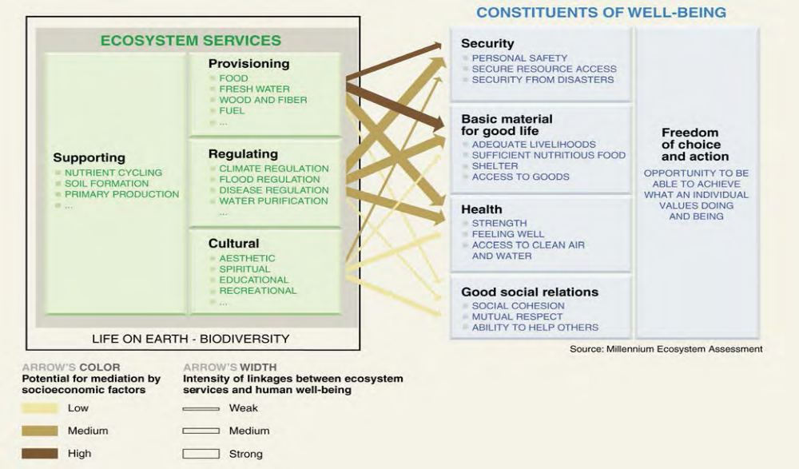
Map 2.1: Ecosystem services provided by forests (Source: NTCA Report 2015)

Another aspect to justify the cost effectiveness of the project is the existing stake RBS Foundation India (RBS FI) has in the landscape. RBS FI has committed a USD 2.55 million (USD 1 = INR 63) grant for 7 livelihood projects covering 220 villages and 16,000 households in the SML (Table 1.6). These projects are implemented with an aim to build community resilience through promotion of sustainable livelihoods In these 7 projects the average grant provided by RBS FI is approximately USD 110 per household per year. Based on this grant amount invested in per household per year and the fact that the proposed project aims to work with 7,500 of the most vulnerable households in the KPC, the grant amount works out to be USD 3.3 million (USD 110 * 7,500 households * 4 Years of project implementation).

However, considering the economies of scale in the proposed project; efficiencies brought in by the experience gained over the years by RBS FI in implementing projects with credible local and national partners, and focus on leveraging ongoing government schemes and other funding sources the proposed grant for the 7,500 households is proposed to be USD 2.52 million.

Taking into account the analysis on i) incremental incomes through sustainable livelihoods, ii) social cost of carbon sequestration and also the fact that RBS FI (project proponent) and its partners have extensive experience in implementing similar projects with sustainable outcomes in the landscape, it is felt that the project is cost effective and will bring returns that are economically as well as ecologically robust and long lasting.

Table 2.10: Summary table with benefits realized by end of Year 4 of project implementation
Project Activity | Expected Monetary Saving calculated by taking average of savings realized at different rates as at completion of 4 years of project implementation | Key Benefits Realized
- Promotion of SRI/improved agricultural package of practices with 6,000 households | - USD 378,000 | - Reduced dependence on inputs, especially water enhancing agricultural resilience against climate change.  - Higher productivity leading to enhanced income from agriculture per unit of land.
- Promotion of alternate livelihoods with 4,000 households | - USD 700,000 | - Availability of Basket of livelihoods leading so as to spread/mitigate risks from failure of agriculture /livestock.  - Enhanced incomes through skill development and promotion of new technology and practices.
- Community Forest Protection to 4,500 ha | - USD 620,000 | - Reduction in forest degradation leading to sustainable carbon sinks.  - Sustainable harvesting of forest resources ensuring long term economic and ecological returns.
- Reduction in fuel wood consumption by 950 tons | - USD 95,000 | - Reduced extraction pressure on forests  - Reduced Drudgery in women/ man animal conflicts
- Reduction in fodder by 4050 tons | - USD 450,000 | - Reduced grazing pressure on forests.  - Improved livestock returns by reduction in death during open grazing.
- Total | - USD 2,243,000 | - Resilient communities and landscape.
Source: RBS FI estimates

- Describe how the project / programme is consistent with national or sub-national sustainable development strategies, including, where appropriate, national or sub-national development plans, poverty reduction strategies, national communications, or national adaptation programs of action, or other relevant instruments, where they exist.

The project aims to build resilience of the KPC and the communities that live in and around it. This is envisaged to be done by implementing an array of interventions that promote development by creating sustainable farm and rural livelihoods on the one hand and improve functionality of the KPC landscape by arresting its degradation to maintain its continuity on the other. The project objectives conform to the current government programs and policies on environmental protection, development of its communities and adaptation towards climate change impacts. The consistency of the project with other relevant ongoing schemes can be understood further in table 2.10.

Table 2.11: Consistency of the Project with relevant Ongoing Government Programs and Missions
S.N. | Central and State  Government Policy | Responsible Agency | Project Component consistent with the Policy
1 | XII Five Year Plan | Planning Commission Government of India | - Increase the forest and tree cover to 33% of the geographical area of the country (Afforestation and Regeneration of degraded Forests)  - Conservation of the existing forests, wildlife and water resources and survey of various areas for identification of new species (Protection of Forests, Conservation of rivers, Biodiversity Conservation, Conservation of Wetlands, Wildlife Conservation, Conservation of resources in the eco-sensitive zone.  - Capacity building, training and research in classical and molecular taxonomy)  - Wildlife conservation, preservation, protection planning, research, education, training and awareness;  - Networking of Government agencies and institutions-  - Ministry of Environment and Forests and Ministries/Departments of the Government of India  - Ministry of Forests and Environment and All States/ UTs Governments.  - Citizens/ Organisations/ Institutions/ NGOs / Universities/ Research Institutions/Industries etc.  - Strategy on Climate Change and promoting Sustainable Development
2. | National Action Plan on Climate Change (NAPCC) June 2008. | Ministry of Environment and Forests, Government of India | The Climate Change Division of MoEF is India's nodal agency for climate change cooperation and global negotiations. It is also the nodal unit for coordinating NAPCC  The National Action Plan on climate change identifies measures that promote our development objectives while also yielding co-benefits for addressing climate change effectively.  It outlines a number of steps to simultaneously advance India’s development and climate change-related objectives of adaptation and mitigation.  In all 8 National Missions have been launched. The ones directly relevant to the project and the ones associated with it may be indirectly are-  - National Solar Mission  - National Mission for Enhanced Energy Efficiency  - National Mission on Sustainable Habitat  - National Water Mission  - National Mission for Sustaining the Himalayan Ecosystem  - National Mission for a Green India  - National Mission for Sustainable Agriculture  - National Mission on Strategic Knowledge for Climate Change
3 | State Action Plan for Climate Change | Madhya Pradesh State Forest and Environment Ministry | Prepared under the central guidelines and are specific to the respective states. Key Strategies for Forestry Sector in Madhya Pradesh issued by SAPCC  - Develop Forest Management (Working) Plans based on the different forest types in view of Climate Change  - Enhance forest conservation, Afforestation (with special emphasis on Compensatory Afforestation) and Reforestation activities through viable models  - Prioritise soil and water conservation measures as part of SFM practices  - Reduce over-dependence on forests for energy by alternate energy sources  - Strengthen forest fire management mechanism throughout the year  - Create corridors for species migration  - Support and develop market linkages for forest based livelihood opportunities  - Impetus to Climate Change relevant research and development  - Study on impacts of Climate Change on MP forests  - Create awareness about CC impacts on MP’s forest types  Key Strategies for Agriculture Sector in Madhya Pradesh issued by SAPCC  - Promote Soil and Water Conservation technologies  - Promote dry land agriculture and horticulture  - Plan for cropping systems suitable for each agro-climatic zone  - Introduce policies for managing climate risks for a sustainable productivity  - Enhancing dissemination of new and appropriate technologies and strengthening research  - Creation of Agriculture Information management including information on climate forecast  - Additional impetus to mechanization and accessibility to markets  - Creation of rural business hubs for diversification of livelihoods  - Capacity building of communities on sustainable harvesting, water management, use of fertilisers, sustainable agri-residue management etc  - Promotion to Climate Change relevant research and development  - Capacity building to integrate Climate Change concerns
4 | National Forest Policy (1894, 1952 and 1988) | Ministry of Environment and Forests, Govt. India | - Maintenance of environmental stability through preservation and where necessary, restoration of the ecological balance that has been adversely disturbed by serious depletion of the forests of the country.  - Conserving the natural heritage of this country by preserving the remaining natural forests with the vast variety of flora and fauna, which represent the remarkable biological diversity and genetic resources in the country  - Increasing sustainability of the forests/ tree cover in the country through massive afforestation and social forestry programmes, especially on all denuded, degraded and unproductive lands.  - Meeting the requirements of fuel wood, fodder, minor forest produce and small timber for the rural and tribal populations.  - Increasing the productivity of forests to meet essential national needs.  - Encouraging efficient utilization of forest produce and maximising substitution of wood.  - Creating a massive people’s movement with the involvement of women, for achieving these objectives and to minimise pressure on existing forests (National Forest Policy, 1988)
5 | National Forestry Action Programme, 1999 | Ministry of Environment and Forests, Govt. of India and State Forest Ministries. | - Sustainability and Sustainable Forest Management  - Ownership and Functional Classification of Forest Resource Base  - Measures to Enhance Forest Resource Conservation  - Forest Resource Expansion through Plantations  - Enhanced and Integrated Natural Forest Resource Manage  - Skill Development and Capacity-building  - Forest Policy and Legislation to Support. Sustainability and  - Critical Role of Forestry Research and Technology Development
6. | National Wildlife Action Plan (1983 Revised 2002-2016 | Ministry of Environment and Forests, Govt. of India and State Forest Ministries. | - Strengthening and Enhancing the Protected Area Network  - Effective Management of Protected Areas  - Conservation of Wild and Endangered Species and Their Habitats  - Restoration of Degraded Habitats outside Protected Areas  - Control of Poaching, Taxidermy and Illegal Trade in Wild Animal and Plant Species  - Monitoring and Research  - Human Resource Development and Personnel Planning  - Ensuring Peoples’ Participation in Wildlife Conservation  - Conservation Awareness and Education  - Wildlife Tourism  - Human Wildlife Conflict
8 | National Rural  Livelihoods Mission | Ministry of Rural Development | The National Rural Livelihoods Mission (NRLM) is, perhaps, the largest poverty reduction initiative, the largest program for women in the world with its goal of reaching nearly 70 million rural households. NRLM will launch in the 12 states that account for 85% of the rural poor households in India. GoI will invest US$5.1 billion in NRLM over next seven years including expected allocation for 12th Five‐Year Plan. The World Bank is committing US$1 billion through its national rural livelihoods project (NRLP)—its largest single investment in a poverty reduction program.  The key results expected of the NRLP and consistent with the project:  - establishment of a sensitive and effective autonomous implementation structures in participating states to facilitate creation of the rural institutional platform;  - increased membership of the rural poor in inclusive, community-managed institutions;  - increase in access to savings, affordable credit and financial services to the rural poor;  - increased amount of resources and services leveraged by the poor from financial institutions, private sector and public agencies; and  - Sustainable increase in productive assets and income from various livelihoods among the rural poor.
 | National livestock mission (NLM) | Ministry of Agriculture  Department of Animal Husbandry Dairying & Fisheries | The NLM objectives consistent with the project:  - Sustainable growth and development of livestock sector, including poultry  - Increasing availability of fodder and feed to substantially reduce the demand – supply gap through measures which include more area coverage under quality fodder seeds, technology promotion, extension, post-harvest management and processing in consonance with diverse agro-climatic condition.  - Accelerating production of quality fodder and fodder seeds through effective seed production chain (Nucleus-Breeder-Foundation-Certified- Truthfully labelled, etc.) with active involvement of farmers and in collaboration with the dairy / farmers cooperatives, seed corporations, and private sector enterprises.  - Establishing convergence and synergy among ongoing Plan programmes and stakeholders for sustainable livestock development.  - Promoting applied research in prioritized areas of concern in animal nutrition and livestock production.  - Promoting skill based training and dissemination of technologies for reducing cost of production, and improving production of livestock sector  - Promoting initiatives for conservation and genetic upgradation of indigenous breeds of livestock in collaboration with farmers / farmers’ groups / cooperatives, etc.  - Encouraging formation of groups of farmers and cooperatives / producers’ companies of small and marginal farmers / livestock owners.  - Providing infrastructure and linkage for marketing, processing and value addition, as forward linkage for the farmer’s enterprises.  - Encouraging community participation on sustainable practices related to animal husbandry, involvement of community in breed conservation and creation of resource map for the states.

- Describe how the project / programme meets relevant national technical standards, where applicable, such as standards for environmental assessment, building codes, etc., and complies with the Environmental and Social Policy of the Adaptation Fund.
Table 2.12: National Technical Standards Applicable for Project Components, and Monitoring
ComponentTechnical Standard Application to the projectMonitoringIntegrated socio - economic assessment and planningPradhan Mantri
Adarsh Gram Yojna (PMAGY). Baseline Survey of a PMAGY Village – GuidelineGuidelines will help identify areas for data collection - for e.g. demographic, housing details, land holding pattern, social dynamics, banking facilities and other socio economic areas. Baseline report - to be made available on public domain.IPCC technical guidelines for assessing climate change impacts and adaptation – 1994Guidelines will help in identifying the best suitable methodology for conducting studies on climate change impacts and measures of adaptationBaseline report - to be made available on public domainCommunity mobilization for building adaptive capacitiesNRLM Hand Book on
Community Capacity Building
Guidelines will help sensitize and mobilize the community members for conservation of forest and adopting sustainable livelihoodsField visit for community interaction, progress reportsGuidelines for convergence of National rural employment guarantee act with integrated watershed management, green India mission and other programsThe project aims to leverage on ongoing government schemes to ensure cost effectiveness and avoid duplication, the framework would help identify the avenues of convergence possible in the landscapeAmount of convergence facilitated under the project, verified by progress reports, field visits and convergence reports.Institutional Framework for Implementing REDD+ in IndiaFramework would provide guidance on how community institutions are to be created in a forested landscape to achieve the conservational and developmental objectivesField visit for community interaction, progress reports, forest land under protection Integrated approach for ecosystem resilience and sustainable livelihoods as a means of adaptationWatershed Guidelines (revised 2001)
Integrated watershed management program
Guidelines will help implement watershed development activities essential for agriculture and building resilience of the landscape against climate changeArea treated, increase in cropping intensity verified through field visits, progress reportsNational mission for Sustainable agriculture - Operational Guidelines – 2014.
Jabalpur University, Krishi Vikas Kendra promoted by the India Council of Agriculture research. Sustainable agriculture practices guidelines will help promote agriculture practices best suited to the landscape including crop selection, irrigation practices other agro practices and promotion of organic farmingAdoption of promoted agricultural practices by the community on a sustainable basis, increase in output/decrease in inputs verified by field visit, beneficiary interactions, progress reportsNational Rural Livelihood Mission - Framework for Implementation
National Biodiversity Act 2002This framework would help assessing the implementation arrangements required in a phased manner for the farm and non farm based livelihoods and how they can be diversified for adaptation towards climate change.Adoption of alternative livelihood skills like poultry, piggery, NTFP processing - change in income - verified by case studies, field visits and progress reportsGuidelines for convergence of National rural employment guarantee act with integrated watershed management, green India mission and other programsThe project aims to leverage on ongoing government schemes to ensure cost effectiveness and avoid duplication, the framework would help identify the avenues of convergence possible in the landscapeAmount of convergence facilitated under the project, verified by progress reports, field visits and convergence reports.Knowledge ManagementGuidelines on Knowledge Management - International fund for agricultural developmentGuidelines will help facilitating the processes by which knowledge on KPC is created, shared and
used.Participation in conferences and progress reports
- Describe if there is duplication of project / programme with other funding sources, if any.

RBS Foundation India has been working in the Satpuda – Maikal Landscape (SML) since 2009 which is the larger landscape with an area of 143,551 sq km within which the proposed project area resides. Majority of these communities are rural (87%) with high dependency on natural resource for their livelihoods. The area is ecologically significant and with 50% of the area under forest, it’s a watershed for 2 important rivers of central India and source of other ecosystem services for the communities. The prevalent poverty and the ecological importance have resulted in putting it on higher priority for development spends by Government and non government agencies.

Based on need assessment and stakeholder consultation, RBS FI has implemented several projects. A total of 7 projects (Table 1.6) with budgets of USD 2.55 million (1 USD = INR 63) have been committed to the region. Also the World Bank and Global Environment Facility have previously funded projects in the region, (Table 1.7). Besides these, there are many other programmes of the Government of India, Government of Madhya Pradesh and civil society organizations that are operational in the area, but most of them are ‘Business as usual’ in fulfillment of the Government Mandate of a particular department or a particular issue. These include projects of the MP Forest Department, NTCA (for Tiger areas), and MP Rural Livelihoods Programme, MNREGA amongst others. Most of these projects do not have comprehensive strategies that can effectively target adaptation. The government programmes are compartmentalized projects of each department and civil society projects are small to achieve scale. Collectively they often operate in ‘extremely water- tight’ compartments.

These are ongoing projects and considering the importance of the landscape there would be more projects that would be implemented in the region in the future. Selection of households and Villages under the proposed project will be done in such a manner that there are no on-going projects in these Villages benefitting the selected Households.

On the basis of our experience of working in the region, we have learnt that conflicting projects and complementary projects can be effectively harnessed to achieve the desired impact and thereby avoiding duplicity is through governance, stakeholder involvement and knowledge management. While we will ensure that this proposal would be implemented in villages where we are not functioning, it would not be possible to concurrently confirm no development activities have been done in the past. Therefore the following strategies have been incorporated in the proposal that are designed to help manage and reduce any potential duplication and overlaps

- Selection Criteria – At the grassroots level, the household selection criteria would ensure selection of those to have lack of alterative available to help adapt. Household that has been benefited from other development projects would automatically get eliminated via this selection process. Villages where RBS Foundation India is working thorough other projects would not be considered for this project.
- Multilevel governance – Local level governance through village level institutions and project level governance through a steering committees. Village level institutions would have participation / representation from all homogeneous groups in the village. The steering committee that has representation from the Headquarters of the Madhya Pradesh Forest Department, District administration and Line departments, Other civil society organizations, academicians, researchers. Both these platforms will help to integrate / compliment the various ongoing and future projects at the demand and supply level. The community governance which is expected to sustain much beyond the project period will ensure project alignment in the future as well.
- Knowledge management – Activities under knowledge management are targeted to create synergies amongst various stakeholders and enhance their effectives in the region. Past forums like the Kanha-Pench Landscape Symposium, Steering meetings and consultations (detailed in Section H) have demonstrated interest from various stakeholders on the need for a more comprehensive approach.

Furthermore, the project will also build on the learning’s and best practices of the GIZ’s ‘Climate Change Adaptation in Rural Areas of India (CCRAI)’ project, and the UNDP-AusAID ‘Climate Change Adaptation’ project and they will be incorporated yet customized to the geographies in Madhya Pradesh where the project will be implemented. The learning’s from both these projects were instrumental in drafting the MP SAPCC and the project intends to use the recommendations of the SAPCC and tackle the climate change issues in the project area.

Learnings from CCRAI project in Madhya Pradesh viz. “Eco-restoration through institution strengthening, sustainable forest management and sustainable agriculture management” in terms of Local level vulnerability assessment, Strengthening village institutions, Promoting agro-forestry, and improved farming techniques would be used in the project proposal development and implementation.

Participatory ground water aquifer mapping approach and preparation of integrated water use action plan through community involvement in Madhya Pradesh have been taken up as interventions under UNDP-AusAID ‘Climate Change Adaptation’. The proposed project would integrate community based resource management based on the learnings from the project.

- If applicable, describe the learning and knowledge management component to capture and disseminate lessons learned.

The primary focus of the project would be to build the adaptive capacity of the community, it would also focus on creating stakeholdership through knowledge management. The role that each stakeholder plays can add or reduce the threats (Section 1.7) to the landscape. Thus, it is important to capture the challenges and opportunities to adopt strong adaptive mechanisms towards these threats which include climate change impacts. The project will conduct a series of workshops, individually and collectively for homogenous groups identified as critical stakeholders of the project area for e.g. the local community, forest department, civil society organizations, private establishments, government line department representatives with the purpose of sensitizing them on their impact on biodiversity conservation and management.

On the basis of the shared outcomes of the workshops, a knowledge management plan will be prepared which will be the guiding document in preparation of customized resource material in reference to each stakeholder. Resource materials such as a curriculum for school staff and students, brochures and pamphlets for villagers in local language and best practices for private establishments will be designed. The process of increasing adaptive capacity basis and the feedback from the workshops will be documented both for knowledge enhancement and to facilitate replication of already existing functioning models. Apart from the models, any others best practices that are followed by the local community or other stakeholders in the project site to cope with existing threats will be identified and distributed for knowledge enhancement.

A website will be designed to host all information on the landscape, threats (including climate change) and its impacts, solutions to problems and information for the stakeholders that would help them build their adaptive capacities and increase resilience. An environmental program and curriculum will be taught at local schools, pamphlets and brochures will be distributed to local community members, NGOs, local government and CBOs through various forums. Training on sustainable business models will be given to private establishments through workshops. An awareness drive will be organized on a quarterly basis in local villages and towns. Posters will be displayed in the prominent villages and nearby towns as well as in many institutions including the schools. Also, lessons from the project will be brought to the attention of state and national level environment and climate change departments through meetings, reports, as well as website postings. Specific targeting of project analysis and policy information will be derived from early assessments of existing gaps or weaknesses in policy matters. In addition, opportunities for dissemination through regional and international conferences, publications in journals and books, or web-based content will be explored by the implementing agency.

- Describe the consultative process, including the list of stakeholders consulted, undertaken during project preparation, with particular reference to vulnerable groups, including gender considerations, in compliance with the Environmental and Social Policy of the Adaptation Fund.

RBS Foundation India with its experience of implementing projects listed in Table 1.6 has taken a lead to adopt a holistic approach of implementation which addresses the threats to the KPC landscape and contributes towards ensuring the long term functionality of the KPC. In this context, it has worked to systemically identify and subsequently consult stakeholders to develop a strong project design ensuring its effective implementation.

The holistic approach which sets the premise of the proposed project makes it essential to engage with stakeholders at different levels of project implementation as the landscape faces competing objectives of conservation, livelihoods of local people, and infrastructure to meet development goals and balancing these objectives so far has presented difficult trade offs. A consultative process is imperative to ensure desired outcomes and sustainability of the project. The stakeholders of the project include local community, community based organizations such as traditional Panchayats, local self-government, grass roots NGOs, government agencies such as the departments dealing with Forest, Revenue and Agriculture and private establishments.

The community has been able to identify the changing temperature, rainfall pattern and change in bio diversity, de forestation as factors that is affecting their livelihood, wellbeing and availability of water. Climate change is an ongoing process and community had traditional knowledge to devise coping mechanism, however with the drastic fluctuations of recent times are too complex for the community to adapt, increasing their vulnerability. This evidently reflects in the consultations process with the community.

To be specific, the community has been able to identify change in rainfall patterns - unprecedented and annually changing wet and dry spells , increase in pest attacks, change and fluctuations (like hail storms) in weather as factors that are affecting the agriculture productivity and forest produce.

Overall, the stakeholders consulted are of the consensus that climate change is a serious issue and it has to be addressed. The level of understanding of climate change varied basis profiles, experiences and background of the stakeholders. For academics, their studies have helped them decipher and understand climate change in the region, for development and conservation practioners, they have had infield experience to develop their analysis and understanding of climate change, the policy makers have incorporated the learning’s of the academics and the practioners and educational institutions are incorporating the concept in their curriculum. The communities have always coped with changes and continue to cope but the sustainability of such existing coping strategies remain an issue for them since the projected changes in climate over the coming years are far more severe than any the communities have been accustomed to in the past.

Even though stakeholders like tourist operators haven’t been directly involved in the consultation process, they will be invited to the knowledge and awareness workshops that will conducted and consultations will be limited to understand the challenges and opportunities in strengthening the resilience of the landscape to address climate change. Tourism in the project area is under the purview of the Madhya Pradesh forest department – the co applicant of the project.
Table: 2.13: Details of Consultative Meetings
Consultation | Date/Place | Participation | Objective | Outcome
Meetings with the community and interactions at the Gram Sabha (locally elected bodies) of the project villages | Date:06.06.15  Place: Village Jogisodha (This is one such meeting in a series of meetings that have been conducted.) Minutes attached as Annexure along with other meetings in recent times as well attached in the Annexure | 35 participants including leaders and members of local self-government, SHGs leaders and members, youth, women and indigenous tribes (Baigas, Gonds) | - To understand the intensity of suffering due to various climatic stresses by grassroot level stakeholders  - Assess interest and willingness to adopt and co-operate with project activities. | - Documentation of various climatic stresses  - Documentation of intensity of threat to livelihoods  - Traditional techniques used to combat climate change are not sufficient  - Documented interest and willingness to sustain the activities implemented to adapt to Climate Change impact.  - Formation of a federation of women SHGs basis a discussion on natural resource management and livelihoods to develop resilience to climate change
Project Intent and Initiation Workshop | Date: 11. 01 .13  RBS Foundation Office, Mumbai | 8 participants including NGOs, researchers, conservationists and RBS Foundation India | - For RBS FI to present their interest in the KPC  - To assimilate interest of other participants in the KPC | - Consensus by all participants on interest and urgency on building the adaptive capacities of all the stakeholders in the landscape from various non-climatic and climatic stresses.  - To put together a plan of action on addressing the threats to the KPC and thereby to the livelihoods of the local community.
Experience Sharing Workshop on Sustainable Lifestyles & Livelihoods in the Kanha-Pench Landscape | Date: 30. 01.13 Place : Khatia Eco-centre, Kanha Tiger Reserve | 48 participants including Forest Department, NGOs, civil society organizations, academics and education institutions  (List of participants will be provided as Annexure in the detailed project report). | - To realize and share concerns arising from the many competing objectives of conservation, livelihoods of local people, and infrastructure to meet development goals  - To formulate ways of balancing these objectives without presenting managers of the landscape with difficult tradeoffs. | - Knowledge Sharing
Kanha – Pench Landscape Symposium | Date: 16.02.13 to  18.02.13  Place: Tulli Resort, Mocha, Kanha Tiger Reserve | 65 participants including Forest Department, NGOs, civil society organizations, academics and education institutions  (List of participants will be provided as Annexure in the detailed project report). | - To bring together researchers, conservationists and managers working in the Kanha-Pench Landscape to share their perspectives and findings,  - Develop networks for collaborative future work in the region. | - Facilitation of mutual understanding and dialogue between researchers and managers to help deliver science based conservation and better outcomes for both wildlife and people in the landscape

Consultative Meeting 1: Project intention and initiation
On 11th January, 2013 RBS Foundation India organized a meeting in Mumbai with NGOs, researchers, practitioners and conservationists with experience working in the proposed project area to present their interest in the KPC and in addressing the threats to it due to climate change and anthropogenic pressures; also an impact of climate change. The conveners spoke of the condition of the project area, the importance of restoring it to its full functionality and building the resilience of the local community to adapt to climate change by ensuring sustainable livelihoods for them. The meeting concluded with an understanding of the urgency to build the adaptive capacities of all the stakeholders in the region from various non-climatic and climatic stresses and ensure the sustainable development of the landscape.

Consultative Meeting 2: Experience Sharing Workshop on Sustainable Lifestyles & Livelihoods in the Kanha-Pench Landscape
On 30th January, 2013 a workshop on experience sharing in sustainable lifestyles and livelihoods in the Kanha-Pench landscape was organized at Khatia Eco-centre, Kanha Tiger Reserve. The workshop, chaired by Dr. P.K. Shukla, Principal Chief Conservator of Forests (Wildlife), Bhopal, included technical sessions with relevant presentations, discussions and culminated in formulation of broad strategies and agreement on action points. The workshop was attended by officers/ scientists of Madhya Pradesh Forest Department and various non-governmental organizations (List of participants will be provided as Annexure in the detailed project report). The participants discussed with concern the many competing objectives of conservation, livelihoods of local people, and infrastructure to meet development goals and balancing these objectives was presenting managers of the landscape with difficult tradeoffs. Discussions concluded with the reaffirmation that a participatory and holistic approach and facilitating mutual understanding and dialogue between researchers and managers could help deliver science based conservation and better outcomes for both wildlife and people in the landscape.

Consultative Meeting 3: Kanha – Pench Landscape Symposium
From February 16th – 18th 2013, a 3-day symposium brought together researchers, conservationists and managers working in the Kanha-Pench landscape to share their perspectives and findings, and develop networks for collaborative future work in the Kanha-Pench landscape. Participants in the symposium which included RBS Foundation India, Madhya Pradesh Forest Department, local NGOS, community representatives and researchers brought to the fore some of the challenges and opportunities in reference to the landscape. The practitioners, beneficiaries and researchers alike focused to exchange ideas and actions directly related to the sustainable management of the Kanha-Pench landscape and its biodiversity. One of the key outcomes of the gathering was to develop a holistic approach to address the challenges to the landscape and strengthen collaboration at various levels to ensure effective implementation. The participants discussed with concern the many competing objectives of conservation, livelihoods of local people, and infrastructure to meet development goals and that balancing these objectives was presenting managers of the landscape with difficult tradeoffs. Discussions concluded with the reaffirmation that a participatory and holistic approach and facilitating mutual understanding and dialogue between researchers and managers could help deliver science based conservation and better outcomes for both wildlife and people in the landscape.

Consultative Meeting 4– Meeting the Gram Sabha (locally elected bodies) of the project villages
Consultative meetings with locally self elected bodies of the villages were organized. Group discussions were the techniques used in the meetings. In one such meeting held on 21.01.2014 this meeting leaders and members of the traditional Panchayat including leaders and members of local self-government, SHGs leaders and members, youth, women and indigenous tribes participated. Grassroots level stakeholders revealed that they were suffering from various climatic stresses which were a threat to their livelihoods and the major cause of their unsustainable dependencies on forest resources for survival. They shared information on some of the traditional techniques that they have been using to combat climate change; however they were not sufficient. During the meeting, villagers showed keen interest to participate in activities that would ensure protection of biodiversity resources and their livelihoods. The respective elected local self-government presidents informed that they would explore and provide support to sustain the activities even after the eventual completion of the project. The community members, local self-government and the landless community expressed their willingness to participate in the project.

- Provide justification for funding requested, focusing on the full cost of adaptation reasoning.

Building adaptive capacities that are effective for communities that requires an approach that is able to bring various complementary and conflicting stakeholders onto a common platform. The communities that live in and around KPC are the major stakeholders and while enhancing their adaptive capacity is the core of the project, the project strives to create an enabling ecosystem that promotes responsible participation from other important stakeholders as well. Component wise justification of the project is as below:
Component 1 - Integrated socio - economic and ecological assessment and planning
In the baseline scenario, while there are several studies and research that have been carried out with varying priorities, no single assimilation of these information, correlating it the Households level situation, its ability or the lack of it to adapt exists.

Adaptation alternative: The KPC landscape is a mosaic of various management categories with outstanding biological, ecological, social, cultural, research, educational, and disturbance regimes. It is also a global priority area for long-term conservation of Tigers and an extremely important functional unit of the SML. With such importance and opportunities, the KPC has attracted many researchers, academicians, civil society organizations and various management units to conduct studies on various socio- economic and ecological aspects and implement conservational and developmental activities. However, the information from studies and learning from projects implemented is isolated, one dimensional and does not enable informed decision making for adopting a holistic approach to negate the prevalent threats to the KPC.

The proposed project envisages adopting a holistic approach of implementation that is based on a comprehensive baseline using a combination of primary and secondary data which integrates the socio-economic-ecological situation of the community and interlinking with the landscape. It is felt that an integrated baseline would result in an integrated assessment which would enable informed decision making for planning and implementation of the project. The comprehensive baseline will be made available on a public domain and will form the principle document for information about the KPC and is expected to form the basis for many studies and management decisions post the project exit as well.

Component 2 - Community Mobilization for building adaptive capacities

In the baseline situation, projects are taken up without consultation of the various stakeholders. The key stakeholders for the projects and also the beneficiary are the most vulnerable communities especially women who are not involved while designing the project deliverables. Their needs, aspirations, difficulties are not factored in while tailoring the project. Their lack of involvement results into misplaced objectives and this reduces the effectives of the implementation and dilutes the impact.

Adaptation alternative: The vulnerabilities combined with the climatic variations have made the community living in and around the KPC increasingly dependent on the surrounding forests. Lack of sensitivity and collective action towards forest protection and practice of primeval livelihood patterns and methods are seen to be the main roadblocks to a resilient community and landscape.

Community mobilization and capacity building are the corner stone of the proposed project. The community would have strengthened capacity to identify and prioritize issue, build knowledge and required skills. The community would be capacitated systematically through a series of training sessions, exposure visits and meetings at village and cluster levels. The capacity building would be done through the span of the project – starting with the planning exercise, implementation, monitoring, and impact assessment. Community’s involvement at all stages of the project is expected to create ownership and therefore responsibility. The cascading impact of this approach in capacity building will be evidenced by enhanced community involvement in other areas of development.

Component 3 - Integrated approaches for Ecosystem resilience and sustainable livelihoods as a means for adaptation

In the baseline scenario, Forest resources for the community are a coping mechanism. The need to cope arises during economic stress occurring at times of livelihood failures like agriculture and livestock. Such failures are expected to rise with climatic change setting in and if such livelihood practices continue it is expected to cause more widespread economic stress periods for the community. Increase in economic stress will further make the community resort to increased extraction of forest resources to cope which can lead to irreversible degradation and fragmentation of the KPC. Distress migration is also used a coping mechanism which leads to many social and physical impacts to the households in the area.

Adaptation Alternative: The project would focus on improvement and diversification of livelihoods in KPC as an imperative to i) make the community resilient against prevalent vulnerability to enable them adapt to climate change impacts and ii) to motivate them economically towards taking collective action towards conservation of forests and the biodiversity it contains.

Under the proposed project livelihood planning would be carried out at the village / cluster level and will be based on the learning from integrated assessment and capacity building phase. A livelihood strategy that will focus on ensuring food security, enhancing income earning opportunities and promoting sustainable harvest of forest and other natural resources would be implemented. Improved agricultural practices like SRI which require optimum input supply, and technology like agromet stations which provide informed agricultural advisories at a local level would be introduced. While interventions like these are expected to address the main livelihood activities in the region, diversification of livelihoods through promotion of alternatives like poultry, dairy, sericulture, ecotourism etc are expected to create new opportunities for the community to generate cash income. Vocational skill training would also be provided to the community so they can earn higher incomes during migratory periods. Specific focus would be given to livestock management as a means for livelihood for the community i.e. convert from a non productive asset to productive assets. The broader plan is to make available a basket of options for the community to have sustained income over a period of time.

Component 4 - Knowledge management for improved understanding on Climate change impacts on the landscape and enhanced involvement of stakeholders

As a base line scenario, there are several functional stakeholders in the area viz. Forest Department, Revenue Department, Civil Society organizations, Academic institutions, Business establishments and the most important of all, the community. These stakeholders have varying degree of stake, dependence and contribution to the region which affects it in both negative and positive aspects. As the stakeholders have different objectives they work mostly in isolation with each other, and in doing so end up adding on to the stress to the community and to the landscape.

Adaptation Alternate: The project proposes to bring all the stakeholders onto a common platform to engage, involve and evolve their involvement in the landscape. It is felt that raising awareness levels of these stakeholders, especially of the community and those involved in developmental activities will increase their sensitivity towards the landscape, the larger implications of isolated activities and actions and ultimately promote landscape friendly practices and activities. Such practices are also in line with modern-day best principles of forest management, tourist management in ecologically sensitive zones, and sustainability. This would be carried out through local and national level consultation and dissemination workshops, symposium etc and a need and gap analysis. Case studies, best practices, knowledge products that are stakeholder specific – like environment awareness program, energy efficiency, animal movement awareness etc would be produced and disseminated. The scientific research would be shared at policy level through National level workshops. Concurrent documentation of project activities and impacts would be shared with stakeholders as ways to improve overall knowledge about the landscape, build popular support and promote better common understanding of KPC management.

- Describe how the sustainability of the project/programme outcomes has been taken into account when designing the project / programme.

Sustainability refers to the continuation of a project’s outcomes, outputs and activities after financial completion, for achievement of its ultimate impact on the target area and affected population. It will require ongoing financial commitment from various sources, including the MP Forest Department and Agriculture Department to enable upkeep of impacted areas and services. Dialogue has been held with the Government, and will continue throughout the project life to ensure these extra services will be provided. A key element in sustainable project outcomes is a design based on a holistic consideration of livelihood systems, needs and opportunities. Narrow, sector-focused interventions can be a risk to sustainability in various ways. For example, in the project area, gains made in income from agriculture by a household can easily be lost due to a livestock depredation. Similarly, improved economic status can be comprised by shocks – natural or manmade – that deplete or destroy household and community assets. In short, if households and communities lack resilience in the face of natural, social or economic shocks, project impacts can be lost quickly.

Given the nature of threats (Section 1.7) to the KPC, sustainability of the project outcomes or solutions to the threats is integrated in the design of the program. An extensive literature and analytical review will be developed that will develop insight into various aspects of climate resilience for the project and which will trigger future research work to be undertaken. A well –documented baseline will be established and used to assess the effectiveness of the project. The baseline use will not be limited to the project personnel as it will be put up on a public domain and will be available on a website developed under the project. The baseline will facilitate improved decision making for important stakeholders like the Forest Department, Agriculture Department, civil society organizations, independent researchers and other government line departments during and post project completion as well.

The measures or interventions will succeed only if the local communities continue their newly resilient livelihoods uninterrupted. The reduction in dependencies of the local communities living in the corridor area will lead to conservation of the resources in the area and thus support adaptive climate change mechanisms. This will be done through the setting up/reviving of CBOs such as Self Help Groups, Joint Forest Management Committees, and Eco-Development Committees. The CBOs will motivate and enable the local community to participate in management of the natural resources, in securing their livelihoods through access to finance and markets and increase awareness of their rights. The setting up of such village level institutions will facilitate community ownership which is integral to the success of the project. To support the community post implementation of project and ensure that continuous support from agricultural extension and other line departments continues, a cadre of village resource persons will be trained who will work for the community on fee basis post project exit and will facilitate line departments’ scheme for the community and manage the existing services/interventions implemented during project period. The village resource persons will play an integral role in the project, especially post exit and would integrate & link the services of departments like agriculture extension and would be a driving force to ensure continuous support and to provide guidance and technical support.

Through periodic workshops, trainings and other knowledge resources, opportunities will be presented to all the stakeholders to systemically address and progress from their issues of concern or those deterring them from achieving the project outcomes. Over and above the monitoring and evaluation that will be undertaken periodically, the Kanha-Pench Landscape symposium and other similar forums will work as platforms to review and contribute to the progress of the project. Learning and challenges in the project will be shared through the website which will be updated and maintained on a regular basis. These will ensure that the project outcomes continue to be realized, not meet a dead end and are replicable in other landscapes with similar dynamics once the project proponents withdraw from the area after completion of the project.

Private sector (tourism operators) will be involved in the project activities to the extent of being invited to these knowledge and awareness workshops that will conducted and consultations will be limited to understand the challenges and opportunities and encouraging participation in strengthening the resilience of the landscape to address climate change.
Dialogue will be held with the resorts in the KPC with regards to best practices in energy consumption and saving, waste disposal, tourist management, etc., and compliance standards that are compatible with natural resource management and wildlife conservation. Similarly, important high-level dialogue will be held in appropriate meetings for transport planning of rail and road link expansions – the project has an important role to play in supporting the case for sustainable forest and wildlife management.

- Provide an overview of the environmental and social impacts and risks identified as being relevant to the project / programme.

Table 2.14: Checklist of Environmental and Social Impacts and Risks
Checklist of environmental and social principles | No further assessment required for compliance | Potential impacts risks – further assessment and management required for compliance
Compliance with the law | The project complies with Forest Conservation Act, 1980, Environment (Protection) Act, 1986, Wildlife (Protection) Act, 1972, Madhya Pradesh Land Revenue Code 1959 (for ownership of land), Madhya Pradesh Panchayat Raj and Gram Swaraj Act 1993 (local governance) and other administrative orders of sub-national government. | None
Access and Equity | The project will provide fair and equitable access to the project beneficiaries and will facilitate access to sustainable livelihoods, clean water, efficient energy and environmental education. While every household/ individual under the project area will have equal opportunity/ access to project interventions, participation of the indigenous tribes.  The risks related to access and equity would be further assessed during consultation process with community and design of interventions, beneficiary selection approach during DPR preparation. | Low
Marginalized and Vulnerable Groups | The project will provide opportunities for tribal including women of these communities residing in the proposed project area to participate in the decision making process for development schemes as well as to enhance their livelihood and incomes and as such will not have any adverse impact on other marginalized and vulnerable groups. Some marginalized and vulnerable individuals / households may not have any means/ assets/ skills to enable them adopt the project activities.  Further assessment would be done based on the vulnerability assessment, demographic data analysis, selection of project interventions, focused group discussion with vulnerable communities, as part of DPR preparation. | Low
Human Rights | The project empowers the communities to exercise their human rights and systemically educates and empowers them to use it to their benefit and development. The project does not foresee any violation of human rights. | None
Gender Equity and Women Empowerment | The project activities will be planned, implemented and monitored by village level institutions with fair and equitable gender representation. Capacity building and skill development training for sustainable livelihood generation will be provided to the women of the village communities as well. This will ensure participation by women fully and equitably, and that they do not suffer adverse effects. While efforts will be made to ensure equal participation of women in interventions and decision making, risks with respect to prevalent social fabric which discourage women participation cannot be out ruled.  Gender analysis would be done as part of DPR preparation and implementation arrangement would be evolved to address any issues related to gender. | Low
Core Labour Rights | Payments to labour under the project area will be made as per Government approved norms duly following minimum wage rate and hence ensuring core labour rights. While full control on non violation of Labour rights will be exercised when labour is being paid using project funds the same cannot be ensured when government schemes are being leveraged and the payment is to be made under a government scheme.  Issues related to core labour rights and process to ensure the same during the implementation would be included as part of DPR. | Low
Indigenous Peoples | Tribal and indigenous peoples have been identified in the project area as vulnerable groups in the project area. They will be considered the key beneficiaries to activities of reducing unsustainable dependencies on forests and to provide sustainable livelihoods.  Further analysis on any risks that may arise with regard to indigenous people and their rights would be part of stakeholder consultation and DPR preparation. | Low
Involuntary Resettlement | Resettlement of communities does not fall within the purview of the project. Forest department carries out resettlements under the provisions of the Wildlife (Protection) Act 1972 and it is completely voluntary. | None
Protection of Natural Habitats | Integrated within the project design is the protection of natural habitats; in this case project area itself i.e. the Kanha-Pench Corridor by enhancing the adaptive capacities of all its stakeholders and ensuring the effective functionality of the services it provides. The project will address the threats of fragmentation that are created by communities, climate change and developmental activities. Community related threats will be addressed by creating governance around extraction of forest resources and through promotion of alternative livelihoods. Threats of climate change will be addressed primarily by addressing the prevalent vulnerabilities of the communities to climate change. Furthermore, it will be addressed by facilitating improved decision making of the Forest department through identifying the specific climate change threats and measures to be adopted to negate the same. Natural habitats may be affected by other developmental activities approved by the government. Like in this case sanction of a new road cutting through KPC can lead to clearing of forests and destroy natural habitats. | Low
Conservation of Biological Diversity | Integrated within the project design are activities that ensure that the flora and fauna within the project area is conserved by reducing the unsustainable dependency of the communities on the forest resources and thereby further reducing man-animal conflict and ensuring biodiversity conservation. Developmental activities and illegal activities like poaching and felling can hamper the biodiversity in the project area.  Consultation would be held with research institutions and forestry institutions to understand any issues related to biodiversity conservation due to proposed interventions. | Low
Climate Change | The project supports enhancing the adaptive capacity of the local community and the KPC against adverse impacts of climate change. Increase in carbon sinks which is a co benefit is also expected to be achieved through project interventions and thus is not expected to contribute to GHG emissions. Droughts and Floods that may or may not be linked to climate change can affect project implementation and impacts. | Low
Pollution Prevention and Resource Efficiency | Project is not expected to generate any environmental pollution and aims for higher resource efficiency for better management of available natural resources. | None
Public Health | No adverse impact on public health related issues is envisaged. | None
Physical and Cultural Heritage | No adverse impact on cultural heritage related issues has been identified. | None
Lands and Soil Conservation, Water Supply | Restoration activities are envisaged to help in land and soil conservation and will not create any damage to land and soil resources. Provision of water supply through rehabilitation of natural micro watersheds, etc., will similarly not create any damage to the environment. | None

The project implementation would include grievance redressed provision for addressing any social and environmental policy violation. The contact details of NIE Coordinator/Contact Person would be available to stakeholders and community would be displayed at common or predominant places along–with the project details. This is expected to promote social auditing of project implementation. Information on the same would also be conveyed during inception workshop.

Considering likely impact of the proposed intervention on some of the environmental and social parameters and requirement to ensure the compliance during implementation the project is proposed to be categorized as “Category B”.

pART iiI: Implementation arrangements

- Describe the arrangements for project / programme implementation.

Broadly, the project implementation structure at the organizational level would be as below, detailed structure and specific responsibilities will be provided at a DPR level.

NABARD

RBS Foundation India
MP Forest Department
Project Steering Committee
Village level institutions
Field entity
Field entity
Field entity
Project Coordinator – Baseline
Project coordinator Capacity Building + Livelihoods
Project coordinator – Knowledge management
Field entity
Field entity
Field entity
Field entity
Field entity
Figure 3.1: Project Implementation Ornogram

Role of Project Proponents

A. RBS Foundation India and Madhya Pradesh Forest Department are the project proponents and would be responsible for execution of the project as per the proposal at the field level. The project proponents’ roles would be as follows:
- Develop a Detailed Project Report on approval of the concept note.
- Identification and validation on implementing partners and execution of agreements.
- Development of annual work plans; management and supervision of project activities
- Procurement, disbursement, and financial management;
- Monitoring and evaluation
- Ensuring compliance with NABARD’s procedures for governance and program implementation.
- Stakeholder engagement

Further details on the specific implementation agreements including the role of implementing partners (NGOs), Government agencies etc will be provided in the detailed project report.

Details of Probable NGOs
Foundation for Ecological Security (FES): FES is a registered non-profit organization based in Anand, Gujarat, India working towards the ecological restoration and conservation of land and water resources in ecologically fragile, degraded and marginalized regions of the country, through concentrated and collective efforts of village communities. FES has been involved in assisting the restoration, management and governance of Common Property Land Resources since 1986. The organization uses a holistic approach to resource management by “intertwining principles of nature conservation and local self-governance in order to accelerate ecological restoration, as well as improve the living conditions of the poor. Most of FES’ efforts are concentrated in the dry land regions of the country making them expert proponents of dryland farming regimes across India; however the landscapes worked on are as diverse as scrub lands, tidal mudflats, dense forests, ravines, grasslands, farm fields and water bodies. Website: http://fes.org.in/ Annual Report available on website.

Professional Assistance for Development Action (PRADAN): PRADAN was formed in 1983 and is a voluntary organization registered under the Societies Registration Act of India. PRADAN believes that the path towards conquering economic poverty is through enhancing the livelihood capabilities of the poor and giving them access to sustainable income-earning opportunities. In the process, the poor must be enabled to break free from their past, develop an alternative vision of their future and set achievable goals. They must be equipped with the technical, organizational, negotiating, and networking skills that will facilitate the fulfilment of their goals. Today, some 400 professionals under PRADAN’s fold are working in the remote villages of India, immersing themselves directly with target communities. PRADAN professionals, divided into 32 teams, have worked with over 271,000 families in 5,000 villages across seven of the poorest states in the country. A majority of the families that PRADAN works with belong to the Scheduled Tribes and Scheduled Castes.Website: http://www.pradan.net/ Annual Report available on website.

Watershed Organization Trust (WOTR): WOTR is a not-for-profit NGO founded in 1993 operating currently in 7 Indian states – Maharashtra, Telangana, Andhra Pradesh, Madhya Pradesh, Rajasthan, Jharkhand and Odisha. WOTR is recognised widely as a premier institution in the field of participatory Watershed Development and Climate Change Adaptation. Its unique strength lies in its ‘on-field’ experience and in a systemic, participatory approach. WOTR was initiated to support a large-scale multi-actor, multi-level, multi- sectoral, community led watershed development program for poverty reduction called the Indo-German Watershed Development Program (IGWDP). WOTR’s mandate is to reduce poverty through mobilising the self help capacities of individuals and communities to regenerate the eco-spaces or watersheds they live in, harvest rain water wherever it falls, use it productively, undertake sustainable livelihoods and do whatever else it takes to get them out of poverty. http://www.wotr.org/. Annual report available on website
Project Steering Committee (PSC)
PSC would comprise representatives of Madhya Pradesh Forest Department, RBS Foundation India, District Administration and Implementing NGO’s. Invitations to participate would also be sent to Line functions responsible for development in the districts such as State Planning Commission, the Panchayati Raj and Rural Development Department, Revenue Department, Education Department of Madhya Pradesh, academicians, etc. The forum would be open to participation by any interested and relevant stakeholder.
The objective of the PSC would be providing guidance to the project and monitoring the progress. Another important role that the PSC would play is to ensure there is alignment of all interventions in the region. The PSC will meet on a half yearly basis.
Project Coordinators
There would be 3 project coordinators for the project. Each coordinator unit will have specific deliverables assigned basis the project implementation plan. The unit would report to the PSC. There would be quarterly review meetings at the coordinator level to ensure smooth operations and address ongoing challenges that arise in day to day management. The composition of each unit would be decided basis the implementation plan.
- Project Coordinator Unit – Baseline
- Project Coordinator Unit – Capacity Building and Livelihoods
- Project Coordinator Unit – Knowledge management

Field Entity
Each Project coordinator would be supported for on field implementation by field entity. A field entity could be an organization or an individual depending on the deliverables. Their tenure would be specific to the expertise and further details would be made available in the DPR.

- Describe the measures for financial and project / programme risk management.

  - To be included in DPR

- Describe the measures for environmental and social risk management, in line with the Environmental and Social Policy of the Adaptation Fund.

  - To be included in DPR

- Describe the monitoring and evaluation arrangements and provide a budgeted M&E plan.

  - To be included in DPR

- Include a results framework for the project proposal, including milestones, targets and indicators.

  - To be included in DPR

- Demonstrate how the project / programme aligns with the Results Framework of the Adaptation Fund

  - To be included in DPR

- Include a detailed budget with budget notes, a budget on the Implementing Entity management fee use, and an explanation and a breakdown of the execution costs.

S N | Project Components | Expected Outcomes | Expected Outputs | Activities | Budget
1 | Integrated socio - economic and ecological assessment and planning | Improved understanding of prevalent landscape dynamics in reference to climate change | 1.1 Baseline report covering the threats, climate change trends and its impacts on livelihoods, biodiversity and ecological security in the KPC | Activity 1.1.1 Project orientation workshops/meetings | 10000
 |  |  |  | Activity 1.1.2 Literature review | 10000
 |  |  |  | Activity 1.1.3 Collection of primary data | 50000
1 |  |  | 1.2 GIS based mapping for climate vulnerability, village settlements, infrastructure (including roads, railways, and resorts) and natural resource base of the KPC | Activity 1.2.1 GIS Mapping | 30000
 |  |  |  | Activity 1.2.2 GIS Analysis | 15000
Sub – Total: Component 1 |  |  |  |  | 115,000
2 | Community mobilization for building adaptive capacities | Enhanced capability of the community to practice adaptive livelihoods and conservation | 2.1 Robust community institutions with active participation of stakeholders at village / cluster / district / landscape level on conservation of landscape for improved ecosystem functionality | Activity 2.1.1 Community awareness, sensitization and mobilization workshops | 50000
 |  |  |  | Activity 2.1.2 Formation and strengthening of Community institutions | 50000
 |  |  |  | Activity 2.1.3 Exposure visits and training workshops for the community | 60000
 |  |  |  | Activity 2.1.4 Gender focused activity | 180000
 |  |  |  | Activity 2.1.5 Participatory impact monitoring | 22500
2 | Community mobilization for building adaptive capacities |  | 2.2 Micro plans are prepared at the village / cluster level for optimal utilization of resources | Activity 2.2.1 Conduct participatory rural appraisal | 13500
 |  |  |  | Activity 2.2.2 Preparation of Micro plans | 37500
Sub – Total: Component 2 |  |  |  |  | 413,500
3 | Integrated approach for ecosystem resilience and sustainable livelihoods as a means for adaptation | Improved adaptive capacity of the community and landscape | 3.1Climate resilient agricultural practices are adopted by the identified beneficiaries | Activity 3.1.1 Identification and demonstration of adaptive agriculture crops and practices | 22500
 |  |  |  | Activity 3.1.2 Development of material for dissemination of best practices and creation of farm schools for adoption | 52500
 |  |  |  | Activity 3.1.3 Supply of agricultural inputs and implements | 215000
 |  |  |  | Activity 3.1.4 Application of efficient irrigation systems / mechanisms | 172000
 |  |  |  | Activity 3.1.5 Installation of agromet stations and dissemination of weather specific agricultural practices | 62500
 |  |  |  | Activity 3.1.6 Promotion of organic cultivation | 75000
3 |  | Improved adaptive capacity of the community and landscape | 3.2 Diversified livelihoods for poverty reduction and enhanced climate change resilience adopted | Activity 3.2.1 Identification and demonstration of alternate livelihood / enterprise options | 12000
 |  |  |  | Activity 3.2.2 Development of material for dissemination and training for wider adoption | 15000
 |  |  |  | Activity 3.2.3 Supply of inputs and implements for adoption of alternative livelihoods | 150000
 |  |  |  | Activity 3.2.4 Facilitation of backward and forward linkages | 28000
3 |  | Improved adaptive capacity of the community and landscape | 3.3 Enhanced vocational skills in the community | Activity 3.3.1 Develop and implement a set of vocations for youth | 105000
3 |  | Improved adaptive capacity of the community and landscape | 3.4 Improved livestock rearing practices to control grazing pressures and reduce man animal conflict in KPC are adopted | Activity 3.4.1 Promotion of improved livestock rearing practices | 210000
 |  |  |  | Activity 3.4.2 Development of pasture land | 31500
 |  |  |  | Activity 3.4.3 Development of Dairy value chain services | 35000
3 |  | Improved adaptive capacity of the community and landscape | 3.5 Energy efficient mechanisms to reduce fuel wood dependency are adopted | Activity 3.5.1 Demonstration and dissemination of energy efficient cooking devices | 12000
 |  |  |  | Activity 3.5.2 Supply of inputs and implements | 120000
Sub – Total: Component 3 |  |  |  |  | 1,318,000
4 | Knowledge management | Improved understanding on threats and climate change impacts on the landscape and enhanced involvement of stakeholders | 4.1 Knowledge management plan covering all main KPC-dependent user groups to improve awareness levels and facilitate informed decision making to address threats to KPC | Activity 4.1.1 Workshops for homogenous groups | 20000
 |  |  |  | Activity 4.1.2 Preparation of a knowledge management plan | 70000
4 | Knowledge management |  | 4.2 Developed pool of products comprising learning, case studies, training modules and capacities for its dissemination through relevant tools | Activity 4.2.1 Develop and design knowledge material and tools | 30000
 |  |  |  | Activity 4.2.2 Documentation of learning and processes | 10000
 |  |  |  | Activity 4.2.3 Develop medium of knowledge sharing | 20000
4 | Knowledge management |  | 4.3 Local and National Level Workshops / Platforms | Activity 4.3.1 Dissemination of knowledge material and tools for identified homogeneous groups | 60000
 |  |  |  | Activity 4.3.2 Dissemination of learning and processes at local and national level through workshops and other mediums | 60000
Sub – Total: Component 4 |  |  |  |  | 270,000
5. Project Execution Cost |  |  |  |  | 201,068
6. Total Project Cost / Amount of Financing requested |  |  |  |  | 2,317,568
7. Project cycle management fee |  |  |  |  | 196,993
8. Amount of Financing Requested |  |  |  |  | 2,514,561

- Include a disbursement schedule with time-bound milestones.

  - To be included in DPR

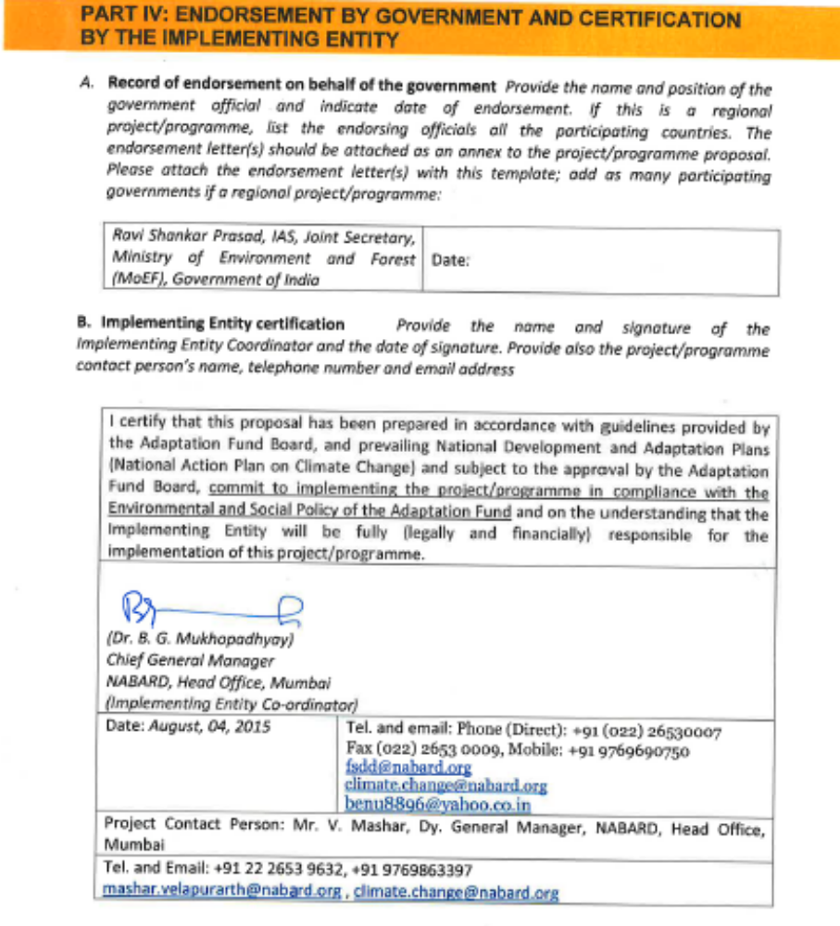

Annexure
Stakeholder Consultation Minutes
English Translation of the Minutes of the SHG Federation
Village: Jogi Sodha
Date: 06.06.2015
The attached minutes signify the forming of a federation of women SHGs, where a discussion on natural resource management and livelihoods happened and the practices that the households could adopt which would increase agriculture productivity and governance around natural resource management.

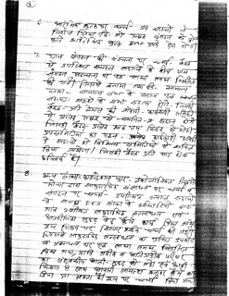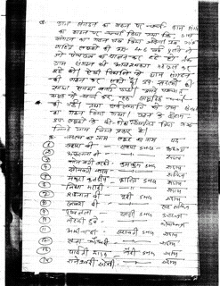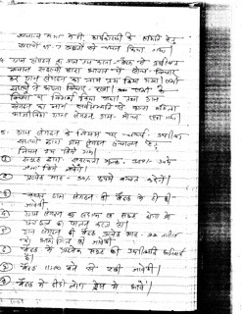

English Translation of the Minutes of the resolutions of Kanskheda village
Village: Kanskheda Village
Date: 09.08.2015
The resolution undertook 3 main decisions:
1. First resolution is about plantation and labour contribution for weeding along the roads.
2. Resolution for labour contribution for repair of a sub-canal (referred as Shakha in the resolution).
3. Resolution on interventions for organic agriculture.
4. Institution asked for Panchayat approval for fish rearing in the village pond.

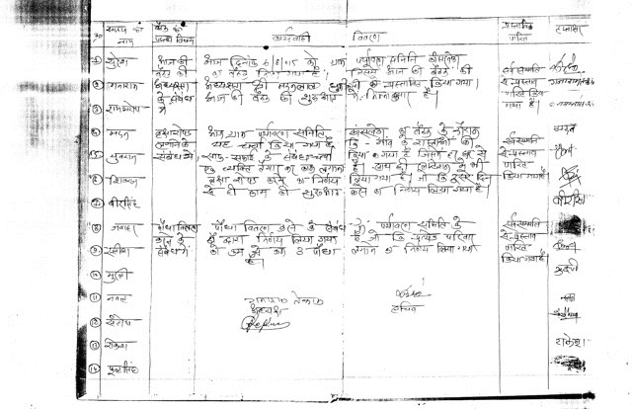
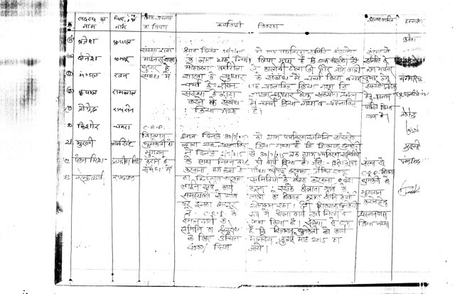
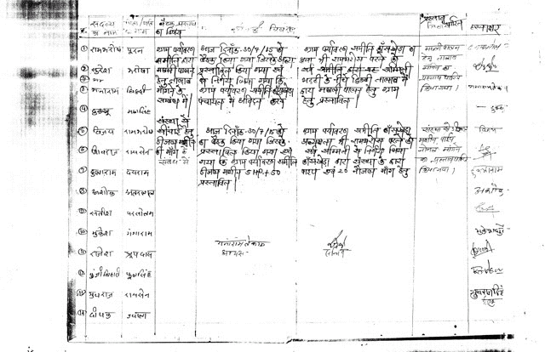

English Translation of the Minutes of the resolutions of Bagaspur Village
Village: Bagaspur Village
Date: 13.08.2015
The resolution of bagaspur vilalge was to acknowledge a mistake in calculating labour contribution, therefore the entire village agreed to contribute one day of labour for the farm pond. The resolution also mentions the rules for certifying measurement of labor in future. (A good example of conflict resolution and strong village institution)

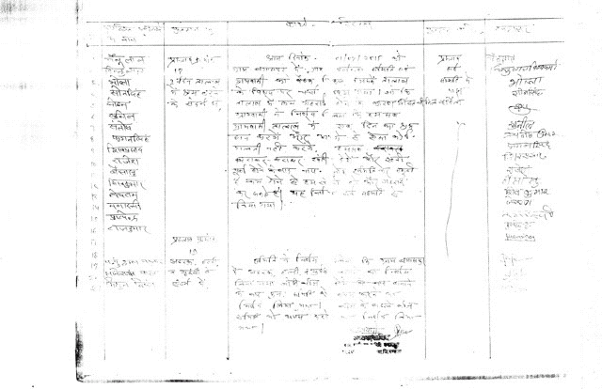

Annexure
references

An area notified under the provisions of Indian Forest Act having full degree of protection. In Reserved Forests all activities are prohibited unless permitted.
An area notified under the provision of Indian Forest Act having limited degree of protection. In Protected Forests all activities are permitted unless prohibited
An Agromet station consists of an automated weather station with a console that has a SIM card inserted within. It transfers weather details on real time basis directly from the place it is installed to the India Meteorological Department (IMD), Pune. IMD then processes this data and shares the analysis with the nearest agriculture department which releases advisories to be disseminated to the farmers.
The interagency process that developed the original U.S. government’s SCC estimates is described in the 2010 interagency technical support document (TSD) (Interagency Working Group on Social Cost of Carbon 2010). Through that process the interagency group selected four SCC values for use in regulatory analyses. Three values are based on the average SCC from three integrated assessment models (IAMs), at discount rates of 2.5, 3, and 5 percent. The fourth value, which represents the 95th percentile SCC estimate across all three models at a 3 percent discount rate, is included to represent higher-than-expected impacts from temperature change further out in the tails of the SCC distribution. Further details on the report will be included in the detailed project report.
Government of India, Ministry of Home Affairs, Office of the Registrar General & Census Commissioner, India, 2011
Government of India, Ministry of Environment and Forests, INDIA'S FIFTH NATIONAL REPORT TO THE CONVENTION ON BIOLOGICAL DIVERSITY 2014
Government of India, Ministry of Environment and Forests, Forest Survey of India, State of Forest Report 2013
FOOD AND AGRICULTURE ORGANIZATION OF THE UNITED NATIONS REGIONAL OFFICE FOR ASIA AND THE PACIFIC, INDIA FORESTRY OUTLOOK STUDY, Bangkok, 2009
Government of India, Ministry of Environment and Forests, INDIA'S FIFTH NATIONAL REPORT TO THE CONVENTION ON BIOLOGICAL DIVERSITY 2014
Government of India, Ministry of Environment and Forests, Forest Survey of India, State of Forest Report 2013
FOOD AND AGRICULTURE ORGANIZATION OF THE UNITED NATIONS, Global Forest Resources Assessment report, 2010
Bunker, D.E., DeClerck, F., Bradford, J.C., Colwell, R.K., Perfecto, I., Phillips, O.L., Sankaran, M., Naeem, S. 2005 Species loss and aboveground carbon storage in a tropical forest. Science 310 (5750), pp. 1029-1031
Bormann, D.B. and Likens, G.E., 1979. Pattern and Process in a Forested Ecosystem. New York: Springer-Verlag.
Government of India, Ministry of Environment and Forests, Forest Survey of India, State of Forest Report 2013
World Wildlife Fund, Introduction to INDIAN FOREST ACT, 1927 INDIAN FOREST (Conservation) ACT, 1980 & WILDLIFE PROTECTION ACT, 1972, FARIDA TAMPAL State Director WWF-India.
Government of India , Ministry of Environment and Forests, Indian Council of Forestry Research and Education, Dehradun FOREST SECTOR REPORT INDIA 2010
ibid
Bharath Kumar L B, Patil B L, Basavaraja H, Mundinamani S M, Mahajanashetty S B, and Megeri S N. 2011. Participation Behaviour of Indigenous People in Non-Timber Forest Products Extraction in Western Ghats Forests. Karnataka Journal of Agricultural Science. 24(2): 170–172
M.G.R. Cannell, UK; R.V.O. Cruz, Philippines; W. Galinski, Poland; W.P. Cramer, Germany, Climate Change Impacts on Forests, IPCC, 2011
ibid
Jhala, Y.V., Qureshi, Q., Gopal, R. and P.R. Sinha. (Eds.) 2011. Status of the Tigers, Copredators, and Prey in India. National Tiger Conservation Authority, Government of India, New Delhi and Wildlife institute of India, Dehradun. TR 2011/003 pp-302
McEuen. A. (1993). The wildlife corridor controversy: A review. Endangered species update, 10 (11 & 12).
Jena, J., Borah, J., Dave, C. and J. Vattakaven. 2011. Lifeline for Tigers: Status and Conservation of the Kanha-Pench Corridor, WWF-India, New Delhi, India.
Compare infobase Pvt. Ltd. http://www.infobase.co.in/ accessed on 14.06.2015
Government of India, Ministry of Home Affairs, Office of the Registrar General & Census Commissioner, India, Madhya Pradesh District Census handbook of Balaghat, Mandla and Seoni2011
ibid
MADHYA PRADESH STATE ACTION PLAN ON CLIMATE CHANGE, Prepared by Climate Change Cell, EPCO, GoMP-UNDP Project, February, 2012
Dubey, Y; Rathore, CS;and Shrivatava, A, 2011. Opportunities for Wildlife Habitat Connectivity between Kanha National Park and Pench National Park in Madhya Pradesh, India
Kanha – Pench Landscape Symposium, http://www.kanhapenchlandscape.com/
Government of India, Ministry of Forest & Environment, Madhya Pradesh Forest Department Kanha Pench Corridor Management Plan
http://documents.worldbank.org/curated/en/1995/02/697630/india-madhya-pradesh-forestry-project
http://www-wds.worldbank.org/servlet/ WDSContentServer/WDSP/IB/1996/09/01/ 000009265_ 3970311115210/Rendered/INDEX/multi0page.txt
Jena, J., Borah, J., Dave, C. and J. Vattakaven. 2011. Lifeline for Tigers: Status and Conservation of the Kanha-Pench Corridor, WWF-India, New Delhi, India.
Government of India, Ministry of Forest & Environment, Madhya Pradesh Forest Department Kanha Pench Corridor Management Plan
Sushant, Impact of Climate Change in Eastern Madhya Pradesh, India
Thakur, R., & Srinu, M. Engendering the Market with Mahua. (2003). Wildlife-Human Conflict revention Strategy. Ministry of water, land and air protection, British Columbia.
Jena, J., Borah, J., Dave, C. and J. Vattakaven. 2011. Lifeline for Tigers: Status and Conservation of the Kanha-Pench Corridor, WWF-India, New Delhi, India.
Sushant, Impact of Climate Change in Eastern Madhya Pradesh, India
Dubey, Y; Rathore, CS;and Shrivatava, A, 2011. Opportunities for Wildlife Habitat Connectivity between Kanha National Park and Pench National Park in Madhya Pradesh, India
MADHYA PRADESH STATE ACTION PLAN ON CLIMATE CHANGE, Prepared by Climate Change Cell, EPCO, GoMP-UNDP Project, February, 2012
Bale JS, Masters GJ, Hodkinson ID, Awmack C, Bezemer TM, Brown VK, Butterfield J, Buse A, Coulson JC, Farrar J, Good JEG, Harrington R, Hartley S, Jones TH, Lindroth RL, Press MC, Smyrnioudis I, Watt AD, Whittaker JB 2002 Herbivory in global climate change research: direct effects of rising temperature on insect herbivores. Glob Chang Biol 8:1–16
Dubey, Y; Rathore, CS;and Shrivatava, A, 2011. Opportunities for Wildlife Habitat Connectivity between Kanha National Park and Pench National Park in Madhya Pradesh, India
Dubey, Y; Rathore, CS;and Shrivatava, A, 2011. Opportunities for Wildlife Habitat Connectivity between Kanha National Park and Pench National Park in Madhya Pradesh, India
Sen, Abhinav IMPACTS OF ECOTOURISM ON KANHA TIGER RESERVE, 2011, Field director’s Office, Kanha Tiger Reserve.
FAO. (n.d.). Waste Water Characteristics. Retrieved June 12, 2012, from www.fao.org/docrep/T0551E/t0551e03.htm.
Jena, J., Borah, J., Dave, C. and J. Vattakaven. 2011. Lifeline for Tigers: Status and Conservation of the Kanha-Pench Corridor, WWF-India, New Delhi, India.
Sushant 2009 Impact of Climate Change in Eastern Madhya Pradesh, India. Tropical (Ref: Conservation Science. Special Issue Vol. 6(3):338-364. Available online: www.tropicalconservationscience.org)
Frazer, L. 2009. Will Warmer Soil Be as Fertile? Environmental Health Perspectives 117:59.
Sushant 2009 Impact of Climate Change in Eastern Madhya Pradesh, India. Tropical (Ref: Conservation Science. Special Issue Vol. 6(3):338-364. Available online: www.tropicalconservationscience.org)
Verma, M., Negandhi, D., Khanna, C., Edgaonkar, A., David, A., Kadekodi, G., Costanza, R., Singh, R. Economic Valuation of Tiger Reserves in India: A Value+ Approach. Indian Institute of Forest Management. Bhopal, India. January 2015
Technical Support Document: Technical Update of the Social Cost of Carbon for Regulatory Impact Analysis Under Executive Order 12866, Interagency Working Group on Social Cost of Carbon, United States Government, May 2013, Revised November 2013
Verma, M., Negandhi, D., Khanna, C., Edgaonkar, A., David, A., Kadekodi, G., Costanza, R., Singh, R. Economic Valuation of Tiger Reserves in India: A Value+ Approach. Indian Institute of Forest Management. Bhopal, India. January 2015
Technical Support Document: Technical Update of the Social Cost of Carbon for Regulatory Impact Analysis Under Executive Order 12866, Interagency Working Group on Social Cost of Carbon, United States Government, May 2013, Revised November 2013
Verma, M., Negandhi, D., Khanna, C., Edgaonkar, A., David, A., Kadekodi, G., Costanza, R., Singh, R. Economic Valuation of Tiger Reserves in India: A Value+ Approach. Indian Institute of Forest Management. Bhopal, India. January 2015

